Lithium-Ion Battery Charger:
This is Lithium-Ion battery charger implemented on Arduino. Has more advanced features like:
- State of charge estimation.
- EEPROM logging.
- Command-Line interface.
It uses the constant current constant voltage (CC-CV).
The rationale behind this project was to upgrade the depleted battery pack and charger of an old cordless drill from Nickel-Cadmium (Ni-Cd) to Lithium-Ion (Li-Ion) technology.
Warning: Lithium-ion batteries are dangerous devices. Overcharging, short circuiting, or misuse of lithium-ion batteries may result in fire and/or violent explosion. It is necessary to equip each lithium-ion battery with its own dedicated battery protection board (or battery management system also known as BMS).
1- Theory of Operation
The following subsections cover the theoretical and mathematical aspects of charging a Li-Ion battery.
1.1- CC-CV Charging
Li-Ion batteries must be charged using the Constant Current Constant Voltage (CC-CV) charging method. This method consists of charging the battery at a constant current I_{charge} until a certain voltage threshold V_{max}=4.2V_{cell} is reached, then gradually reducing the charging such that the constant cell voltage V_{max} is not exceeded. Charging is terminated once the current reaches a certain minimum threshold I_{full} of typically 50-150 mA.
Additional End of Charge (EOC) standards have been implemented for safety reasons. These include time-based and capacity-based EOC detection. When the battery is connected, the charger measures the voltage at its terminals. The SOC value is used to calculate the remaining capacity C_{max} and charging duration T_{max}. Charging is terminated if any of these values ​​are reached.
1.2- Control Loop
The battery “+” terminal is connected to the positive power supply through a power MOSFET (field-effect transistor). The battery “-” terminal is connected to the power supply ground through a low-value shunt resistor R_{shunt}.
The charging current is regulated by pulse width modulation (PWM), where the MOSFET is periodically turned on and off by the Arduino at a frequency of 31,250 kHz. The charging current is controlled by gradually adjusting the PWM duty cycle which is the ratio between the ON and OFF duration of the MOSFET.
V₁ is the voltage measured at the “+” terminal of the battery and V₂ is the voltage measured at the “-” terminal of the battery. Both voltages are measured relative to the power supply ground and are used to calculate the voltage V across the battery pack and the charging current I as follows:
$V\left(Volt\right)=V1-V2$
$I(Ampere)=\frac{V2}{R_{shunt }}$
Two separate ADC channels on the Arduino are used for measuring the above voltages. The Arduino continuously monitors V and I and adjusts the PWM duty cycle in order to achieve the desired constant current or constant voltage regulation.
1.3- State-of-Charge Estimation
The state of charge SOC is estimated by reading the battery voltage V and comparing it to a series of values stored in a lookup table L = (l0, l1, l2, l3, l4, l5, l6, l7, l8). The threshold voltages are derived from the particular discharge curve shown below for the LG 18650 HE4 cells used in this project. (Source: https://lygte-info.dk/review/batteries2012/LG%2018650%20HE4%202500mAh%20%28Yellow%29%20UK.html).
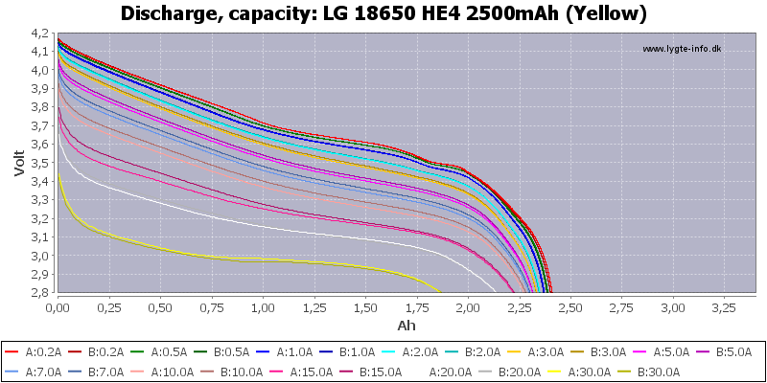
Figure 1: Statistic of Discharge, capacity (LG-18650-HE4-2500mAh)
The red discharge curve corresponding to 0.2A discharge current has been used, whereas the values of L were assigned such that:
- Ɩ₀= V~2.25Ah
- Ɩ₁= V~2.00Ah
- Ɩ₂= V~1.75Ah
.
.
.
- Ɩ₈= V~0.25Ah
SOC is calculated as follows:
- V< Ɩ₀: SOC= 0%
- Ɩ₀<V< Ɩ₁: SOC= 10%
- Ɩ₁<V< Ɩ₂: SOC= 20%
.
.
.
- Ɩ₈<V: SOC= 90%
The remaining capacity C_{max} and charge duration T_{max} are derived as follows:
$$C_{max }(mAh)=C_{full }×(100-SOC)×1.3$$
$T_{max}=3600×\frac{C_{full }}{I_{charge }}$ × (90 – SOC) + 45.6
Where C full is the design capacity of the battery and C is the nominal charging current. Note that C_{max} is increased by 30% and T_{max} is increased by 45 min in order to account for resistance losses and inaccuracy of SOC estimation.
1.4- Safety
The charger implements several safety features. These include:
- Undervoltage.
- Overvoltage.
- Short circuit.
- Open circuit detection.
The typical voltage range where a Li-Ion battery can safely operate is between $V_{min }= SI\left(2.5\right)V_{cell }$ and $V_{max }= SI\left(4.2\right)V_{cell }$ . Operating outside this range is likely to cause permanent damage to the Li-Ion cells and may even result in a catastrophic failure such as an explosion or fire.
In addition, the battery pack is protected by a battery protection board (or battery management system also known as BMS). The BMS measures the voltages of individual battery cells as well as the charging and discharging current flowing through the battery. The BMS uses a solid-state switch to disconnect the battery once the voltage or current values ​​become outside the specified limits.
For the most part, the BMS is completely transparent and does not interfere with the charging process, except for the case where the BMS disconnects the depleted battery in order to prevent over-discharge. In this case, the voltage of the depleted battery is still present across the BMS terminals through a high value resistor placed in series with the battery. This high value resistor causes a much lower voltage value to be measured at the charger terminals. Consequently, the charger must ignore the V_{min} lower limit and start charging at a much lower value of as low as $V_{start }= SI\left(0.5\right)V_{cell }$.
When served with a depleted battery, the charger will start charging at a low safety current $I_{safe }=\frac{I_{charge }}{10}$ until the battery voltage reaches $V_{safe }= SI\left(2.8\right)V_{cell }$, after which full charging current I_{charge} will be applied. Once the voltage reaches this threshold, it is no longer allowed to drop below V_{min}. A voltage lower than V_{min} may cause an “under voltage fault” which may be caused by either a short circuit or open circuit of the battery.
Open circuit is also detected if the charging current stays equal to zero while the PWM duty cycle increases beyond a specific threshold. This condition would raise an “open circuit error”.
Overvoltage is detected whenever the battery pack voltage momentarily exceeds $V_{surge }= SI\left(4.25\right)V_{cell }$. Exceeding this value would raise an “overvolt error”.
1.5- Trickle Charging
Once the end-of-charge (EOC) criteria has been met, the charger would cut-off the charging current and switch to an idle mode where it will continuously monitor the battery voltage. Once the voltage drops below a specific threshold of $V_{trickel/start} = SI\left(4.10\right)V_{cell }$, a new charging cycle will be initiated using the following parameters:
$$V_{max }(V_{cell })=V_{trickel_max}=(4.15)V_{cell }$$
$$C_{max}(mAh) =C_{full}×0.3+C$$
$$T_{max}(s)=20×60+T$$
Where C_{full} is the battery design capacity. C and T are the accumulated charge capacity and charge time since the battery has been connected, including the initial charge and all of the subsequent trickle charge cycles.
Given the above formulas, the trickle charge cycle uses a reduced V_{max} and allows for charging up to a maximum of 3% of the battery design capacity during a maximum duration of 20 minutes.

2- Hardware
The following sub-sections describe the hardware design aspects of the Li-Ion charger.
2.1- Mechanical Design
We used four LG 18650 HE4 Li-Ion cells and a battery protection board (or battery management system also known as BMS). Modern lithium-ion cells use much less space.
2.2- Battery Protection Board
It is necessary to use a dedicated battery protection plate for each battery pack. This provides an extra layer of protection to prevent over charging or over discharging due to software or hardware malfunction.
in figure 2 below, it shows the 4S/30A (4S means 4 cells in series) battery protection board (or BMS).

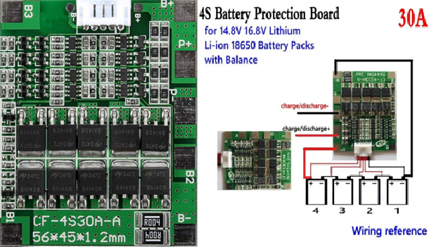
Figure 2: 4S Battery Protection Board
In figure 2 can see the wiring diagram for connection the 4 Li-Ion cells with the BMS.
This particular BMS includes the cell balancer feature. If the voltage of one or more cells becomes higher than the rest of the pack, the BMS would actively discharge those cells to ensure that all the cells of the battery pack share the exact same voltage.
3- Circuit Diagram
In figure 3 below, it shows the Li-Ion charger circuit diagram.
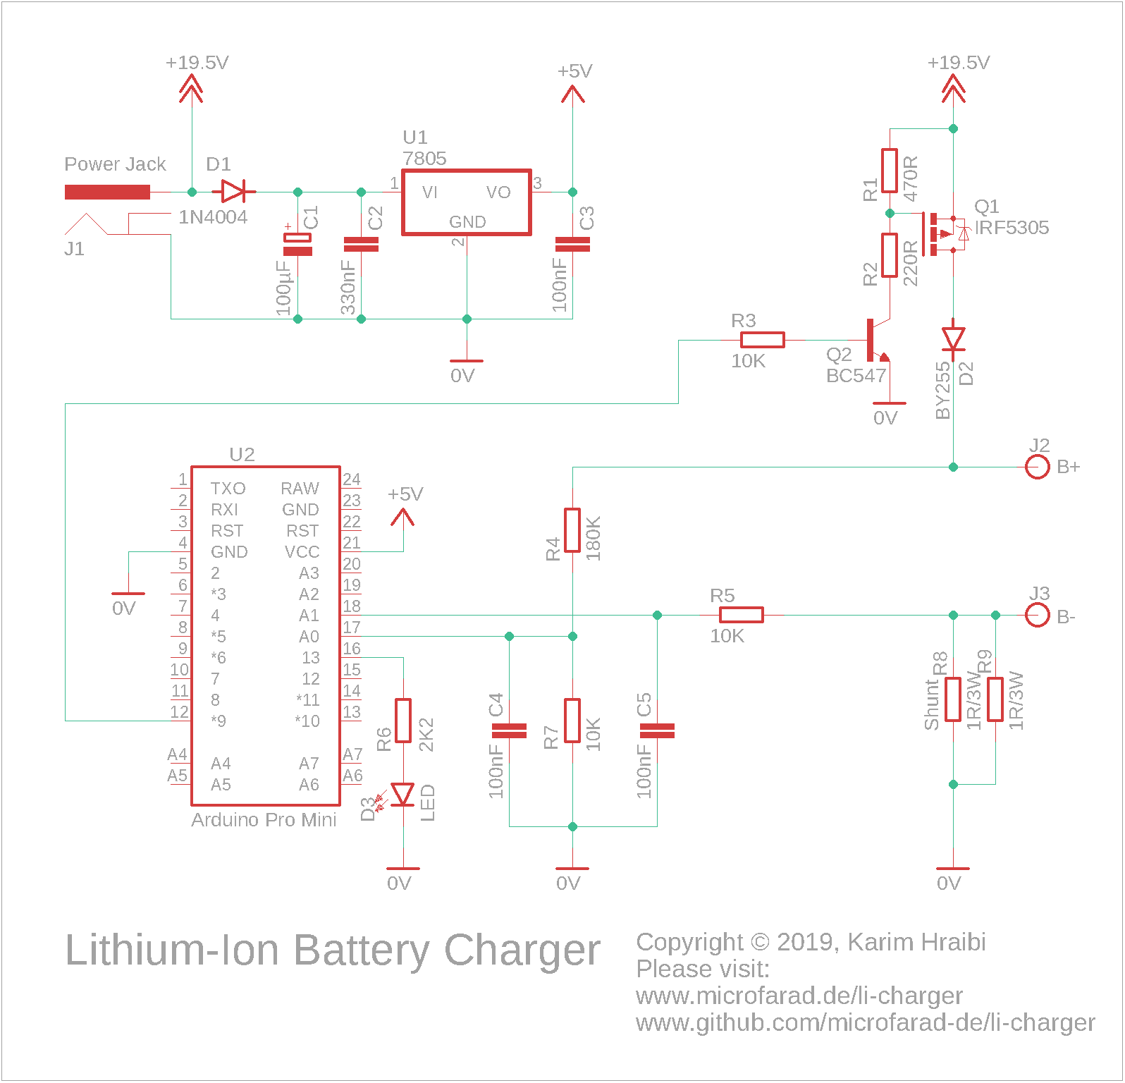
Figure 3: Li-Ion charger circuit diagram
In figure 3 above schematic, the 19.5 V of the power supply are stepped-down to 5 V by the 7805-voltage regulator U₁. The 5 V is used for powering the Arduino board.
The Arduino Pro Mini compatible board U₂ hosts an AT-mega 328P microcontroller running at 16 MHz clock frequency and is used as the main processing unit for the device.
The Lithium-Ion battery is connected across the B+ and B- terminals. The battery charging current is regulated by switching P-Channel MOSFET (field-effect transistor) Q₁ via pulse-width modulation (PWM).
The PWM-enabled digital output pin 9 on the Arduino generates a PWM signal which drives the gate of the MOSFET Q₁ through the NPN transistor Q₂. The voltage divider formed by R₁ and R₂ ensures that the gate-source voltage of the MOSFET stays within the specified limits.
A current-sensing shunt resistor connects the B- terminal with ground. It consists of two 1 Ω / 3 W resistors R₈ and R₉ connected in parallel. This results in a total resistance of 0.5 Ω. At a charging current of${ I}_{charge}=2A$, the voltage across the shunt will be exactly 1 V; which is slightly below the 1.1 V internal voltage reference of the Arduino thus corresponds to the full range of the Arduino’s analog-to-digital converter (ADC).
The analog pin A₀ on the Arduino is used for measuring the voltage V₁ between B+ and 0 V. and the Analog pin A₁ is used for measuring V₂ between B- and 0V.
B+ is connected to pin A₀ through a voltage divider consisting of R₄ and R₇, the ratio has been chosen such that the maximum battery pack voltage of 16.8 V would result in slightly less than the Arduino’s internal reference voltage of 1.1 V at A₀. Please note that the value of R₄ needs to be adapted to the number of cells in use. For example, using a 1 cell setup would require reducing the value of R₄ to 39 KΩ.
B- is connected to A₁ through a current-limiting resistor R₅; A voltage divider is not required for measuring V₂ as its value stays below the Arduino’s ADC internal reference voltage.
Two 100 nF capacitors C₄ and C₅ are used for blocking the high-frequency noise caused by the PWM from reaching the analog inputs, an essential measure for smooth ADC readings.
The Diode D₁ protects the 7805 regulator from a reverse power supply polarity. The diode D₂ protects the battery from a reverse polarity. it also prevents the battery from feeding power back into the Arduino in case the main power supply has been disconnected.
A LED indicator D₃ and its dropper resistor R₆ are connected to Arduino’s digital pin13.
Important: The battery terminals in the circuit diagram are labeled as B+ and B-. It is important to connect these terminals to the P+ and P- terminals of the Battery Management System (BMS) depicted in the figure 3. The BMS has its own set of B+ and B- terminals that must be connected directly to the battery terminals. It is crucial to avoid connecting the charger’s B+ and B- terminals to the B+ and B- terminals of the BMS, as this would bypass the BMS and prevent it from safeguarding the battery against overcharging.
3.1- Different Number of Cells
The following values for R₂, R₄ and the power supply voltage need to be chosen in order to charge different numbers of Cells:
N_{cells} | Power Supply | R₂ | R₄
1 | 5V-6V | 220Ω | 39KΩ
2 | 10V-15V | 100Ω | 82KΩ
3 | 14V-20V | 220Ω | 120KΩ
4 | 18.5V-20V | 220Ω | 180KΩ
Table 1: N_{cell} with Power Supply, R₂, R₄
When charging 1 cell, the following circuit modifications must be performed:
- Remove the voltage regulator U₁ and capacitor C₃ and power the Arduino directly from the output of D₁.
- Replace Q₁ with a IRLML2244 MOSFET.
- Increase R₁ to 10 KΩ.
- Remove Q₂ and R₃.
- Connect R₂ directly to Arduino digital pin 9.
- Modify the code in li-charger.ino to invert the PWM signal by subtracting the PWM duty cycle from 255 within all instances of analogWrite () using one of the following statements in the figure below:
Figure 4: code of analogWrite () in li-charger.ino
4- PCB Layout
All components are of the punch-hole type and are mounted on a PCB board. The Figure 4 shows the PCB layout of a Li-Ion charger.
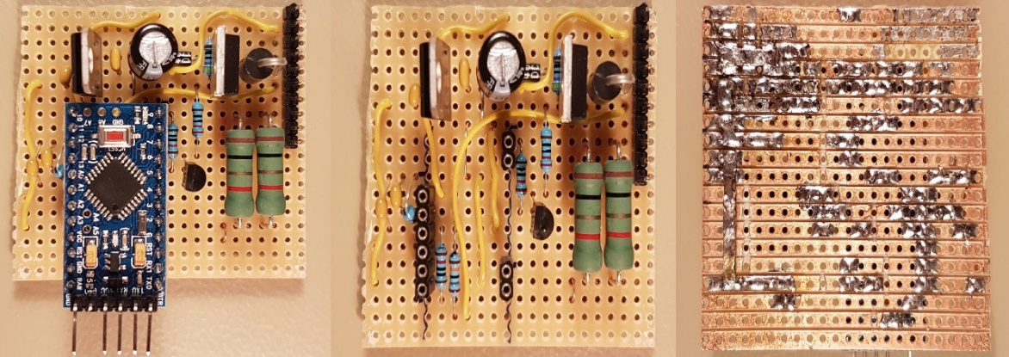
Figure 5:PCB layout of the Li-Ion charger
The MOSFET Q₁ (TO-220 device in the top right corner) and large green-colored shunt resistors will get pretty hot so adequate ventilation needs to be assured. The following measures has been taken to avoid overheating:
- The shunt resistors R₈ and R₉ are raised by around 5mm from the PCB in order to assure adequate cooling.
- A series of holes has been drilled in the bottom of the enclosure in order to allow for a better air flow.
- The charging current I_{charge} has been limited to 1.5 A.
The electrolytic capacitor C₁ towards the top center of the board is in a sub-optimal position due to its location between two hot components, the 7805 regulator and the MOSFET. High temperatures reduce the lifespan of electrolytic capacitors thus the must be kept away from heat sources.
The pin header located at the top right corner is used for connecting all the external wires. Following is the pinout assuming that pin 1 is at the top right corner and pin 10 is towards the middle of the board.
Pin | Purpose
1 * | LED +
2 * | LED -
3,4 ⸸ | Power supply +
5,6 ⸸ | Battery +
7,8 ⸸ | Power supply -
9,10 ⸸ | Battery -
Table 2: All pinhead work
* The LED dropper resistor is located on a separate PCB together with the LED itself.
⸸ Two pins are connected in parallel in order to increase their current capacity.
5- User Interface
The following sections describe the user interface of the Lithium-Ion charger. It consists of a LED indicator and a Command-Line Interface (CLI).
5.1- LED Indicator
The charger status is displayed by turning on or flashing a single LED as shown
in Table 3.
Blinking Pattern | Meaning
On for half a second every 2 seconds | Ready, waiting for the battery to be connected
Solid on | Battery charging
On For 0.1 second every 2 seconds | Battery fully  charged
Blinking fast (0.4 s period) | Error
Blinking very fast  (0.2 s period) | Calibration  mode
Table 3: The meaning of what is displayed via the LED
5.2- Command-Line Interface
This Lithium-Ion battery charger features a Command-Line Interface (CLI) that can be accessed via the Arduino’s RS232 serial port. The easiest way to connect to the CLI is to open the serial monitor of the Arduino IDE while connected to the charger using a FTDI USB to Serial converter. Please ensure that the Baud rate is set to 115200.
Once up and running, the charger will display a welcome message on the serial monitor, show the current firmware version and present with the list of available commands shown in the following list.
Some of these CLI commands need to be provided with arguments. Thus, one needs to enter the command followed by one or two arguments separated by a white space. SSS
Command | Description
h | Help- show the list of available commands
. | Display the real-time parameters, including the charge duration T, charge capacity C, battery voltage V, charging current I, maximum charge duration T_{max}, maximum charge capacity C_{max}, maximum charging voltage V_{max}, maximum charging current I_{max}, PWM duty cycle, voltages V₁, V₂ and their raw ADC values V_{1, raw} and V_{2, raw}
r | Show the list of calibration constants that are stored within EEPROM
t | Show the contents of the trace circular buffer
ncells  <integer> | Set the total number of cells within the battery pack N_{cells}, the value provided as an argument will be validated and stored in EEPROM
cfull  <integer> | Set the battery design capacity C_{full} in mAh, the value provided as an argument will be validated and stored in EEPROM
ichrg  <integer> | Set the battery charging current I_{charge}, the value provided as an argument will be validated and stored in EEPROM
ifull  <integer> | Set the end-of-charge current I_{full} in mA, the value provided as an argument will be validated and stored in EEPROM
iut  <index>  <voltage> | Configure the state-of-charge lookup table (LUT). This command takes and index $i=0,1,2,…,8$ and the reference voltage l_{i} in mV as arguments. Each time this command is called, a new reference voltage value l_{i} is populated into the LUT and stored into EEPROM, more on this in the following section
rshunt  <integer> | Set the shunt resistor value R_{shunt} in mΩ, the value provided as an argument will be validated and stored in EEPROM
cal  <start|stop|v₁|v₂>  <mv> | The voltage calibration mode is entered by calling cal start and exited by calling cal stop.V₁ is calibrated using cal v₁ <mv>.V₂ is calibrated using cal v₂ <mv>.<mv> is the measured voltage level in millivolts. Please refer to the next section for more details about the calibration procedure.
Table 4: command followed by one or two arguments separated
5.3- Calibration Procedure
This section provides an example on how to perform the first-time calibration of the Lithium-Ion battery charger using the CLI over the serial monitor.
The calibration values are stored into the Arduino’s electrically erasable programmable read-only memory (EEPROM). A cyclic redundancy check (CRC) checksum is appended to the configuration parameters set and stored into EEPROM as well. All configuration parameters are validated and out-of-range values are automatically replaced with the corresponding failsafe values.
The current example assumes a system consisting of N_{cells}= 4 connected in series having a design capacity of C_{max}= 2500mAh charged using a current of I_{charge} = 1500mA.
Important:
- Do not connect the battery during the calibration procedure unless instructed otherwise.
- Ensure that the voltage calibration procedure has been properly executed and verified prior to attempting to connect a Lithium-Ion battery. It is mandatory to connect a good quality battery protection board between the charger and battery. Failing to observe these precautions may lead to permanent damage or even explosion of the Lithium-Ion cells.
5.3.1- Initial ranking
A first step, the initial configuration parameters need to be loaded into EEPROM by executing the command sequence as shown in figure 6 below:
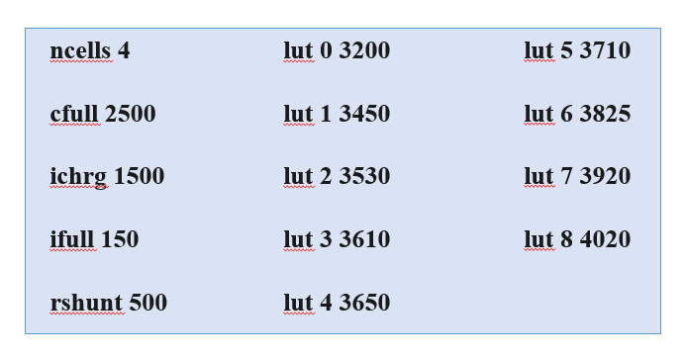
Figure 6: command sequence
A confirmation message will be printed on the serial monitor following each value entry.
5.3.2- Voltage calibration
Having performed the above initial step, please proceed for calibrating the ADC readings for the voltages V₁, V₂ as shown below:
- Enter the Cal start command in the serial monitor, this will activate calibration mode. The Start Calibration message should appear on the serial monitor.
- Connect a constant voltage source of approximately 750 mV between the B- terminal and the power supply ground, and measure its exact value using a digital multimeter. Note that 750 mV corresponds to 1.5 A flowing through the shunt resistors R₈ and R₉.
- Enter the command cal v₂ <value> into the serial monitor, where <value> is the value in mV of the voltage measured in the previous step. The value of the calibration constant V_{2,cal} will be displayed upon the successful calibration of V₂. If the calibration fails, the message Out of range will appear in the serial monitor.
- Connect a constant voltage source of approximately 16800 mV (4200 mV per cell) between the B+ terminal and the power supply ground, and measure its exact voltage using a digital multimeter.
- Enter the command cal v₁ <value> into the serial monitor, where <value> is the value in mV of the voltage measured in the previous step. The value of the calibration constant V_{1,cal} will be displayed upon the successful calibration of V₁. If the calibration fails, the message Out of range will appear in the serial monitor.
- Verify the voltage calibration by applying a known voltage to each of B+ and B- (relative to 0 V), then enter the [.](dot) command and check the displayed values for V₁ and V₂ which must match the measured voltages at B+ and B- as closely as possible.
- Repeat steps 2, 3, 4, 5 and 6 until the voltage V readings are correct.
- Enter the command cal stop in order to exit the voltage calibration mode. The message Calibration stop should appear on the serial monitor.
5.3.3- Current calibration
Please proceed with calibrating the reading of the current I by following the steps below:
- Connect a discharged lithium-ion battery in series using a digital ampere meter (set to the 10 A range) to terminals B+ and B-.
- The message Charging should appear in the serial monitor and the measured current value should start to gradually increase until it reaches a maximum of approximately
1.5 A.
- Enter the [.] (dot) command and check the displayed value for I which must match the measured current as closely as possible.
- If the output of the [.] command is higher than the ampere meter reading: Increase the R_{shunt} value by 10 mΩ by calling the r_{shunt} command.
- If the output of the [.] command is lower than the ampere meter reading: decrease the R_{shunt} value by 10 mΩ by calling the r_{shunt} command.
- Repeat steps 3, 4, and 5 until the current I readings are correct.
5.4- Trace Buffer
A lithium-ion battery charger records events that occur during the charging process in a circular buffer within the available EEPROM space. The contents of the trace buffer are dumped using the t command. Here is a sample trace log output for a complete shipping cycle as shown in figure 7 below:
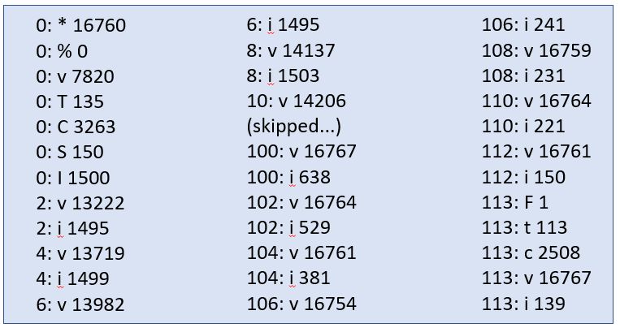
Figure 7: t command
Trace messages have the format <timestamp>: <event> <value>. While the timestamp counts the minutes that have passed since the beginning of the charging process. The following table shows the available events and their descriptions:
Event | Description
* | Beginning of the charging cycle, indicates the maximum battery voltage V_{max} in V
% | Initial charge state %
T | Maximum permissible charging time T_{max} in minutes
C | Maximum permissible charging capacity C_{max} in mAh
S | Safety charging in progress, I_{safe} is indicated in mA
I | Normal charge in progress, indicates I_{charge} in mA
v | Instantaneous battery voltage V=V₁-V₂ in mV
i | Instantaneous battery current I in mA
F | Battery full, indicates the end-of-charge condition (1 = I_{full} reached, 2 = C_{max} reached, 3 = T_{max} reached)
t | Actual charging time T in minutes
c | Actual charged capacity C in mA
E | Error (1 = over-volt, 2 = under-volt, 3 = open-circuit, 99 = CRC fail)
Table 5: Available events and descriptions
6- Download:
Below you can find GitHub download links for the Arduino firmware source code, Eagle schematic source files and bill of material. All of the source code is distributed under the GNU General Public License v3.0.
Please note that the current implementation uses the watchdog timer functionality which requires the customized Arduino bootloader found under the link below. For more details, please follow the installation instructions found within the README file on GitHub.
Customized Arduino Bootloader
Lithium-Ion Charger Firmware
Eagle Schematic Source Files
Bill of Material

