

|  |  |
| --- | --- |
| AECENAR_Kopf_withWebsiteAdress_kleiner | MEGBI_logo  **MEGBI - Middle East Genetics and Biotechnology Institute**  **مركز أبحاث للجينات والتقنية البيولوجية**  <http://aecenar.com/index.php/institutes/megbi> |

**Quantification of produced Penicillin (Report 2021)**

* **Improvement of Lab Scale Penicillin Quantification**
* **Improvement of Quality Assurance (Determination of penicillin)**

Last update: Saturday, December 4, 2021

**Authors of Document:**

Hind Abd El Hamid, Jana Hamzeh, Alaa Bzal

**Editor:**

Samir Mourad



Table of Contents:

[**I-** **Basics** 3](#_Toc89425277)

[**Characterization of purified penicillin:** 3](#_Toc89425278)

[**Penicillin production qualitative analysis:** 3](#_Toc89425279)

[**1-** **Microbiological assay** 3](#_Toc89425280)

[**2-** **HPLC analysis of penicillin** 4](#_Toc89425281)

[**II-** **Experiment:** 6](#_Toc89425282)

[***References:*** 7](#_Toc89425283)

# **Basics**

## **Characterization of purified penicillin:**

Characterization of purified extract and crude extract of penicillin was finally analyzed for its activity on three different pathogenic organisms, *i.e*., *Klebsella* spp., wild strain of *Escherichia coli* (*E. coli*), and methycillin resistant *Staphylococcus aureus* (MRSA). A bacterial lawn of the foresaid bacterial species was spread on nutrient agar plate and a well was bored on the bacterial agar plates. And randomly selected samples which had a high rate of inhibition during routine assay were used for characterization. 100 µL of the samples from crude and purified extract were loaded in two different wells bored in a single plate. The plates were kept for inhibition at 37 °C for 16 to 24 h, and the results were noted(1).

## **Penicillin production qualitative analysis:**

### **Microbiological assay**

The qualitative analysis was done through β-lactamase test using penicillin resistant *Staphylococcus aureus*. Briefly, filter paper was soaked in 0.2% bromophenol blue and 2% culture sample from different shake flask culture medium. The filter paper was dried and loopful culture of penicillin resistant *S. aureus* was placed on it. The change in color was noted to see the presence of β-lactamase enzyme and to confirm the penicillin production. Quantitative analysis was performed by measuring the diameter of zones of inhibition of all the culture samples and comparing them with the standard curve drawn by measuring the diameter of zones of inhibition of standard dilutions of commercially available penicillin G(2).

Antibiotic diffusion assays are based on the technique of allowing an antibiotic to diffuse through an agar gel which has been previously seeded with a sensitive test organism. This diffusion may be of two types: (a) linear diffusion, by bringing the antibiotic in contact with a column of seeded agar in a capillary or test tube; and (b) radial diffusion around a suitable reservoir on a seeded agar plate. Linear diffusion methods have been developed by both Japanese and American workers for penicillin and streptomycin; however, linear diffusion techniques require specialized equipment and are not in general use. The plate assay method for antibiotics is the most widely used and accepted method employing the diffusion technique. Its advantages lie in its simplicity as to labor and equipment. It has definite disadvantages in that the assay is affected by various salts, surface active agents, and solvents which tend to change diffusion characteristics of the antibiotics. With alterations in the diffusion characteristics the dose response curves of the sample and standard will no longer be parallel and the assay itself would be invalid. The distribution of an antibiotic in the agar around a reservoir can be expressed theoretically by an equation involving the initial quantity of antibiotic, the depth of the agar layer, the diffusion constant, the concentration at a given distance from the container, and the time of diffusion. Theory predicts that the square of the diameter of the inhibition zone will be proportional to the logarithm of the antibiotic concentration. This relationship has been found to hold for most antibiotics. Good assay plate methods are available for penicillin, streptomycin, bacitracin, and polymyxin; however, the newer broad spectrum antibiotics tend to give poorly defined zone edges on assay plates(3).

#### **Factors influencing variability and error in microbiological assays:**

Microbiological assay provides a valid measure of antibiotic activity with some   
problem of interference from biologically active compounds or degraded products.   
Several factors are investigated by scientists that normally cause variation in zone diameters in conventional agar diffusion bioassay. Among these factors the most considerable is the unequal exposure of the individual plates at the top or bottom of the stacks. Another major variable is the variable in the time interval between pouring seeded agar in the plates and the time of applying the solution of the antibiotic to the plates. Other factors that lead to variability and error in microbiological assay include agar thickness, inoculums concentration, incubation temperature, exposure-time duration and sample preparation. Factors affecting microbial growth rates include pH and chemical composition of media and pH of buffer solution used(4).

### **HPLC analysis of penicillin**

HPLC is a chromatographic technique used for the identification, quantification and purification of individual components of a mixture in analytical chemistry. HPLC is used extensively throughout the pharmaceutical industries for the quantification of antibiotics in pharmaceutical preparations. It is used to provide information on the composition of drug related samples.

The information obtained may be qualitative, indicating what compounds are present in the sample, or quantitative, providing the actual amounts of compounds in the sample. HPLC is used at all the different stages in the creation of a new drug, and is also used routinely during drug manufacturing. It is more attractive than the classical bioassay in terms of speed, accuracy and precision. Hence, it has largely replaced the microbiological assays to determine the antibiotic concentrations in body fluids and pharmaceutical preparations(4). HPLC analysis of penicillin was carried out with UV detector set at 254 nm. The column used for analysis is C-18. The mobile phase consisted of methanol: phosphate buffer (85:15, v/v) at flow rate 1 mL/min. Standard used for comparison is Pencom®13 (commercially available penicillin injection)(1).

The literature finding shows that both microbiological assay and HPLC method exhibit several advantages and inadequacies. Although HPLC method is fast, accurate and precise for quantification of potency of antibiotics, it cannot determine bioactivity. However, microbiological assay is simple, sensitive, accurate, precise and cost effective to estimate both potency and bioactivity. Besides this, microbiological assay become the most important method to quantify the concentration of active ingredient required for the inhibition of growth of antibiotic resistant microorganism(4).

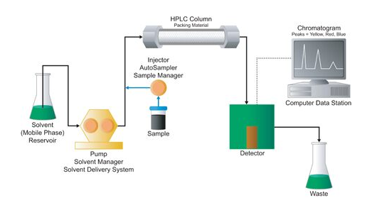

# **Proposed experimental protocol:**

## **Preparation of the turbidity calibration 0.5 McFarland**(5)**:**

1. we added 0.5 mL of a 0.048 mol/L solution of BaCl2 (1.175% w/v BaCl2 2H2O) to 99.5 mL of a 0.18 mol/L solution (0.36 N) of H2SO4 (1% v/v) and we shook vigorously
2. We checked the density of the suspension using a spectrophotometer with a 1 cm beam and matching cuvettes. The absorbance at 625 nm should be between 0.08 and 0.13
3. We distributed the suspension in tubes of the same size as those used to adjust the inoculum and then we sealed the tubes
4. Once sealed, we stored these tubes at room temperature and protected from light. Before use, we mixed the tube vigorously using a Vortex (6 months’ storage)



## **Quantification of the produced penicillin using the disk diffusion method (Kirby-Bauer Test)**(6)**:**

**Preparation of the inoculum:**

1. We took 3 to 5 colonies of the isolated colonies with a loop, and we added them in 2ml sterile saline (NaCl 0.9%)
2. We Vortex the saline tube to create a smooth suspension.
3. We adjust the turbidity of this suspension to a 0.5 McFarland standard

by adding more organism if the suspension is too light or diluting with

sterile saline if the suspension is too heavy.

1. Use this suspension within 15 minutes of preparation.
2. We inoculate the surface of Mueller Hinton agar plate by streaking the swab 3 times over the entire agar surface, we rotated the plate approximately 60֯ each time to ensure an even distribution of the inoculum
3. We allow the plate to sit at room temperature at least 3 to 5 minutes (but no more than 15 minutes) for the surface of the agar plate to dry before proceeding to the next step

**Preparation of the disks:**

1. We dilute the standard penicillin 10 times (1.5; 1.4; 1.3; 1.2; 1.1; 1.0; 0.9; 0.8; 0.7; 0.6) to obtain different concentrations
2. We dip each of the 10 discs in one of the 10 concentrations of penicillin
3. We dip another one disk in the unknown produced penicillin
4. We distribute the 11 disks in plates at a distance of (26) mm apart
5. Once all disks are in place, we replaced the lid, inverted the plate and placed it at 37oC for 18 to 24 hours

**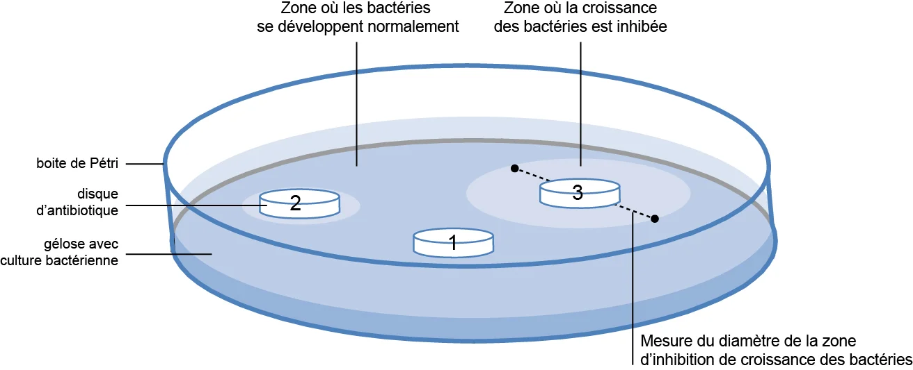**

**Quantification of the produced penicillin:**

1. After the growth time, we measured the zone of inhibition that had appeared using a ruler
2. We drew a graph showing the concentration of penicillin as a function of the diameter in order to be able to quantify the produced penicillin (Log C as a function of diameter)

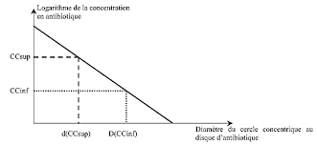

# ***References:***

1. Dayalan SAJ, Darwin P, Prakash S. Comparative study on production, purification of penicillin by Penicillium chrysogenum isolated from soil and citrus samples. Asian Pac J Trop Biomed. 2011 Jan;1(1):15–9.

2. Rahman S-U, Rasool MH, Rafi M. Penicillin production by wild isolates of Penicillium chrysogenum in Pakistan. Braz J Microbiol. 2012 Jun;43(2):476–81.

3. DAVID GLICK. METHODS OF BIOCHEMICAL ANALYSIS. Vol. 1. 1954.

4. Dafale NA, Semwal UP, Rajput RK, Singh GN. Selection of appropriate analytical tools to determine the potency and bioactivity of antibiotics and antibiotic resistance. J Pharm Anal. 2016 Aug;6(4):207–13.

5. Antibiogramme | Protocole | Interprétation [Internet]. [cited 2021 Dec 2]. Available from: https://microbiologie-clinique.com/antibiogramme.html

6. Kirby-Bauer-Disk-Diffusion-Susceptibility-Test-Protocol-pdf.pdf [Internet]. [cited 2021 Dec 4]. Available from: https://asm.org/getattachment/2594ce26-bd44-47f6-8287-0657aa9185ad/Kirby-Bauer-Disk-Diffusion-Susceptibility-Test-Protocol-pdf.pdf