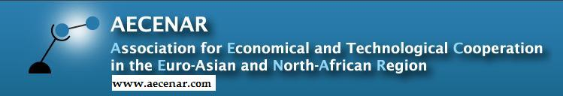

Telecommunication

Author: Maryam Abdel-karim

Contents
1. Telephone 3
2. Free radio and television broadcasting 4
3. Paid radio and television 4
4. Internet services 4
5. ADSL services 4
6. Broadband Internet 5
7. ISPs (Internet Services Providers) 5
8. DSPs (Data Service Providers) 6
9. Statistics 6
9.1. Landline 6
9.2. Internet 7
9.3. DSL 8
9.4. Mobile cellular 12
9.5. Telecom One Stop Shops (OSS) 13
9.6. THE FIXED NETWORK: THE TRANSITION FROM COPPER WIRE TO FIBER OPTICS (FTTX) 14
9.7. THE MOBILE NETWORK: THE TRANSITION FROM THE THIRD GENERATION (3G) TO THE FOURTH GENERATION (4G ADVANCED) 17
10. Country profile 18
10.1. Country Rank 18
10.2. Strengths 19
10.3. Opportunities 19
10.4. The Four Technology Enablers 19
10.5. The four pillars 20
10.6. The 40 Indicators 20

- Telephone
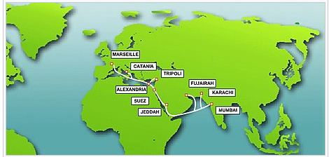
The I-ME-WE (India-Middle East-Western Europe) submarine communication cable linking Tripoli, Lebanon with other countries.
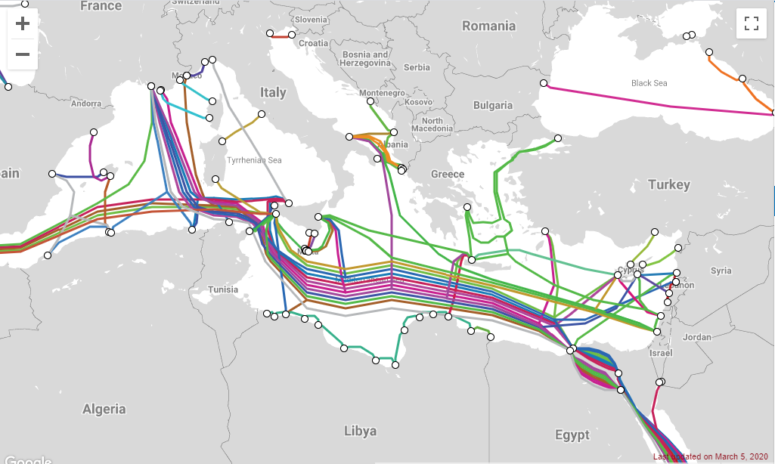
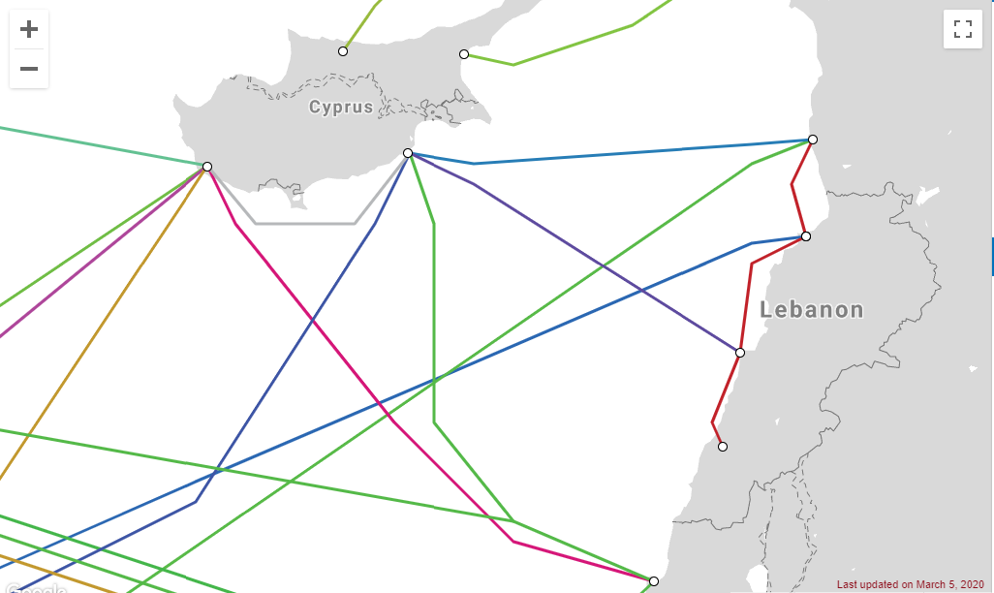
There are 1,816,262 landlines giving a relatively high fixed line penetration rate, along with 4,890,534 mobile telephones in use in Lebanon. The telephone system was severely damaged during the civil war but was completely rebuilt and revamped. The systems that provide the infrastructure for the telephone network are, domestically, microwave radio relay stations and cables, and internationally, two Intelsat satellite-earth stations, a microwave radio relay station to Syria and three international undersea fiber optic cables: I-ME-WE, CADMOS (to Cyprus), and BERYTAR (to Syria).
- Free radio and television broadcasting
Lebanon possesses one AM radio broadcast station, and 32 FM radio broadcast stations. In 2005, there were 28 privately owned FM radio stations. One FM station, which shifts between French, English, and Armenian, and the sole AM radio station, which broadcasts solely in Arabic, are owned by the state-owned Radio Lebanon, which is under the jurisdiction of the Ministry of Information. Radio Lebanon also relays Radio France International at 13:00 (UTC) daily. Among private broadcasters are Mix FM, PAX Radio, the Lebanese Broadcasting Corporation(LBCI), National Broadcasting Network, Radio One, and the Voice of Tomorrow. There are 2.85 million radios is Lebanon. In 1998 Lebanon's radio penetration rate was 906 radios per 1000 people. Furthermore, Lebanon has five digital cable television companies, Cable Vision, Digitek, EcoNet, City TV and UCL.
There are 28 television broadcast stations in Lebanon, although the application of the audiovisual law has caused the closure of a number of TV stations. The PAL television standard is used in Lebanon. Other than the state-owned Télé Liban, most broadcasters are privately owned and earn revenues from advertising. Some of the most important television networks are the LBC, Murr TV, Al Jadeed, Future TV, Orange TV (OTV), Al-Manar, NBN, Télé Lumière, and Télé Liban (State-owned). There are 1.18 million television sets in Lebanon.
- Paid radio and television
There are five cable TV companies in Lebanon: Cable Vision, Eco Net, City TV, Digitek and UCL.
- Internet services
The development and growth of internet infrastructure has been particularly slow in Lebanon due to corruption and allegations of a sector monopoly.
Internet services are administered in Lebanon by the Ministry of Telecommunication. Lebanon provides three types of services: dialup services, wireless Internet service and ADSL. Lebanon ranks 161 on the netindex.com (as of 1 February 2019).
- ADSL services
ADSL was offered for the first time in April 2007 and there were, as of July 2011, 1,284,361 subscribers. The ADSL network has been undergoing large upgrades throughout the country. The addition of the new IMEWE underwater cable during the summer of 2011 has dramatically increased Lebanon's international bandwidth capacity, allowing for increased speeds and larger data caps. The prices for ADSL varies slightly depending on the DSP but typically cost from $16/month (4 Mbit/s) to $65/month (open speed) on unlimited data plans.
To fix the problem, the Ministry of Telecommunications signed an 18-month contract with Consolidated Engineering & Trading and French/American Company Alcatel-Lucent to install a Fiber Optics grid. It was expected that by the end of 2011 all the areas of Lebanon will have fast internet ranging from 10–15 Mbit/s download, and 20 Mbit/s and more will be available the year after, allowing Lebanon to finally catch up with the rest of the world, which eventually never happened. A new fiber-to-the-home initiative was launched in 2015 by the Ministry of Telecommunications under Boutrous Harb. It is expected to be fully implemented by 2020, presenting users with VDSL2+ plans capable of offering speeds reaching 150Mbit/s.
- Broadband Internet
Wireless Internet services were offered for the first time in 2005 to palliate for the absence of an ADSL infrastructure at the time. ISPs fees revolve around $45/month. Wireless internet is portable: users can connect nearly anywhere through a receiver (connected to the client via USB or Ethernet) and it provides download rates between 2 Mbit/s and 9 Mbit/s depending on the chosen plan. Coverage weakens in densely built areas or remote locations.
- ISPs (Internet Services Providers)
There are 17 licensed ISPs (Internet Services Providers) and 9 licensed DSPs (Data Service Providers) operating in Lebanon:
- Broadband Plus
- ComNet
- Cyberia
- Data Consult (Managed Services Provider)
- Farah Net
- Fiberlink Networks
- IDM
- Keblon
- Lebanon OnLine
- Masco Group
- Mobi
- Moscanet (Wise)
- Onet Plus
- Pro Services
- Sodetel
- Solidere
- Terranet
- Transmog (Cyberia)
- Tri Network Consultants
- Virtual ISP (VISP)

- DSPs (Data Service Providers)
Cable One, Cedarcom, GlobalCom Data Services, Pesco, Sodetel, Solidere, LCNC S.A.L., TRISAT S.A.R.L., Waves S.A.L.
- Statistics
  - Landline
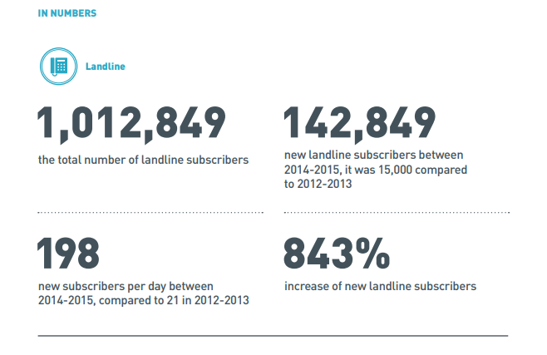
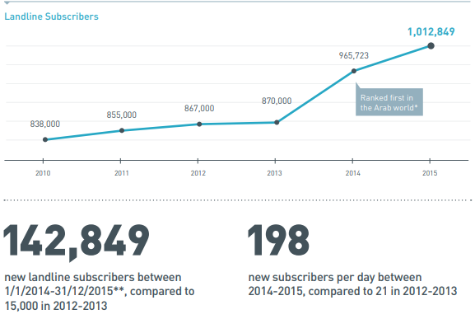
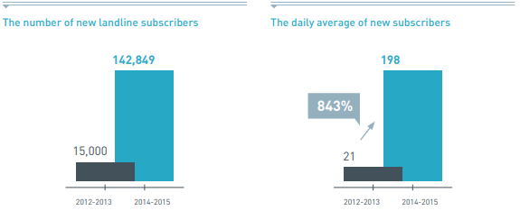
  - Internet
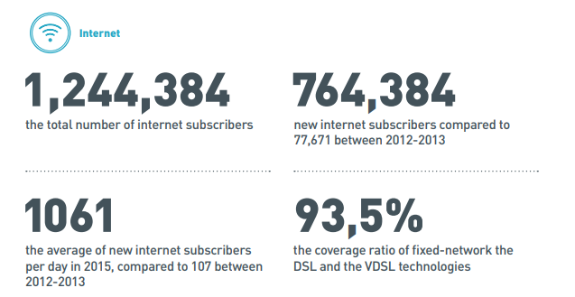
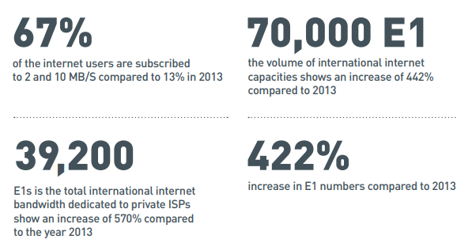
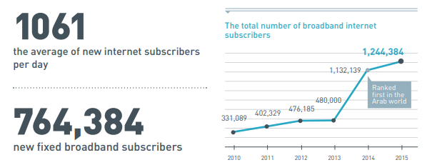
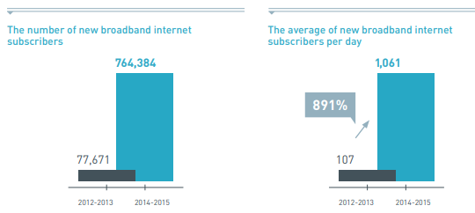
  - DSL
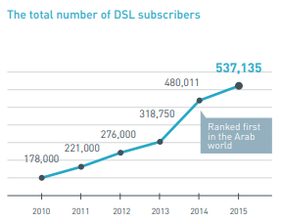
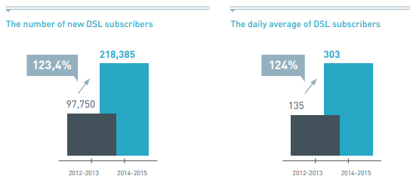
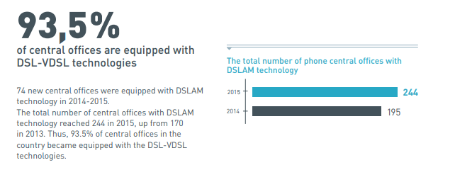
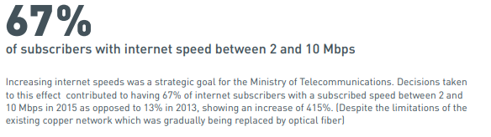
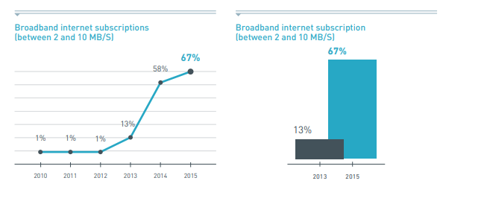
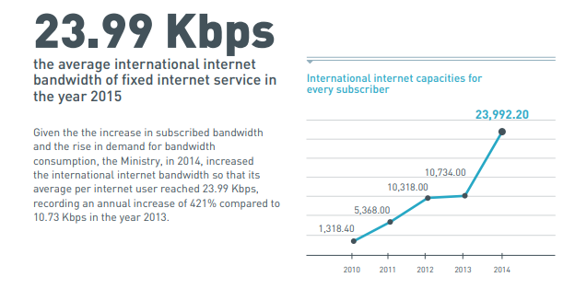
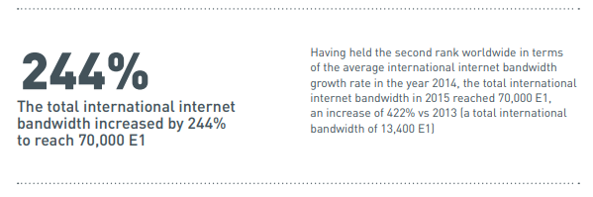
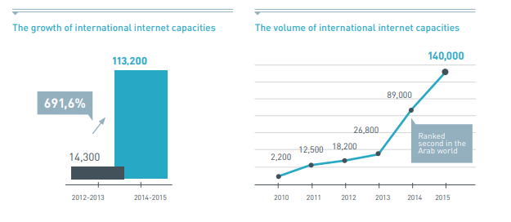
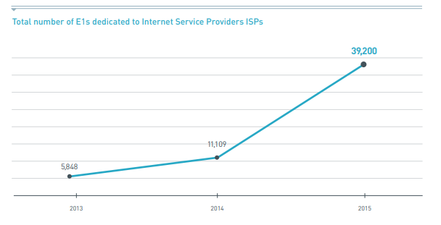
  - Mobile cellular
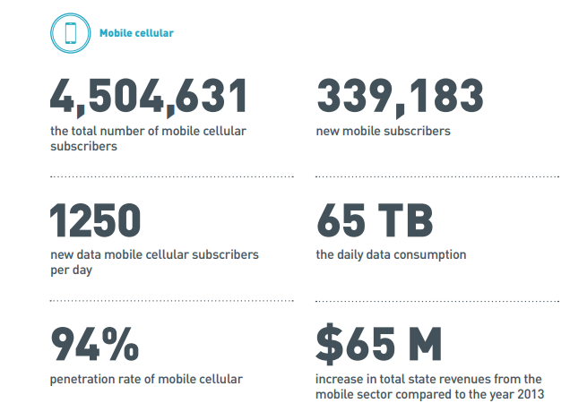
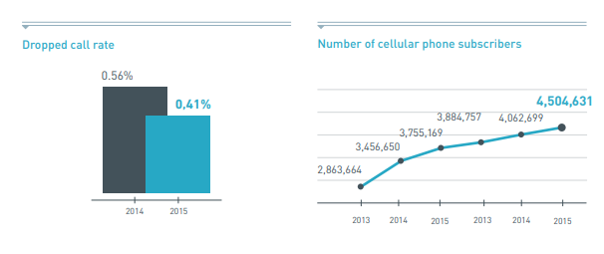
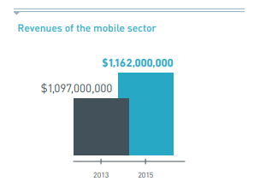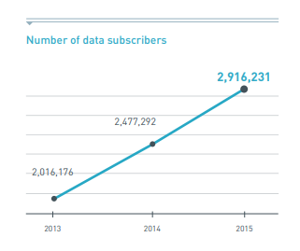
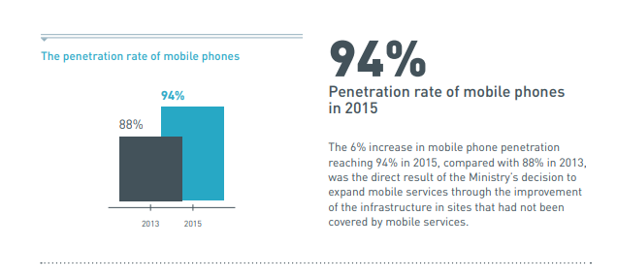
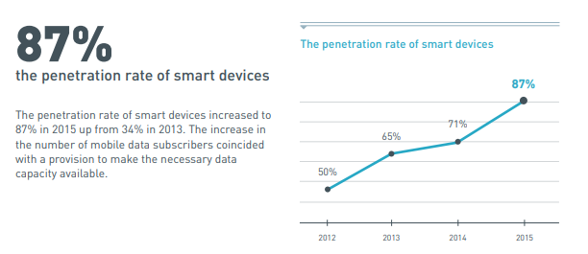
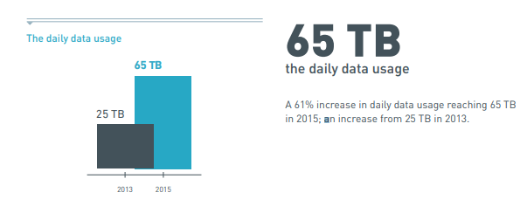
  - Telecom One Stop Shops (OSS)
Common sale centers (Telecom One Stop Shops) for Alpha, Touch and Ogero were set up to provide fixed and mobile telecommunications services. Telecom One Stop Shops were the first moment of truth in the process of developing and modernizing the telecommunication services; be it for fixed or mobile networks. The OSS were the implementation of the decentralized and sustainable management strategy that allowed consumers to experience improved services at a much lower cost across the Lebanese territory, be it at urban centers or rural areas. The One Stop Shops implementation plan consisted of three phases. Twenty-six centers out of a planned thirty-six were set up as part of the OSS operation.
Operational telecommunication OSS Zouk Mikayel, Jbeil, Miniyeh, Halba, Tripoli (4 centers), Batroun, Zgharta, Bcharreh, Amioun, Douma, Tanourine, Elyssar, Badaro, Aley, Hazmieh, Shekka, Jdeideh, Antelias, Mazraah, Sidon, Zahleh, Chtoura, Saghbin. These newly introduced common centers for Alpha, Touch and Ogero provided consumers (citizens, residents and tourists ) various services, namely the sales of fixed and mobile mobile lines, internet services, bill settlement, and prepaid cards, among others. In addition to the existing 44 centers, 19 new Ogero centers were set up and in full operation bringing the total number of Ogero offices to 63 nationwide.
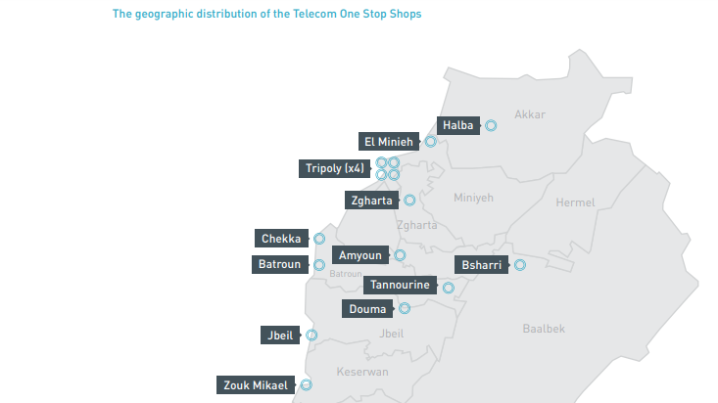
  - THE FIXED NETWORK: THE TRANSITION FROM COPPER WIRE TO FIBER OPTICS (FTTX)
This strategic objective aimed to connect homes, institutions, office buildings, and neighborhoods with the “FTTX” technology, which has become standard in developed countries. That objective required the development of the telecom national network infrastructure, namely the “local loop” as well as the “last mile”. It also required a complete transition from the current copper network to the optical fiber network: Ambitious developments that were to be implemented according to a tight schedule based on technical and economic criteria associated with the cost of implementation and existing quality of service.
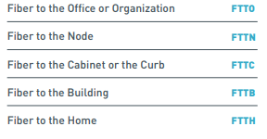
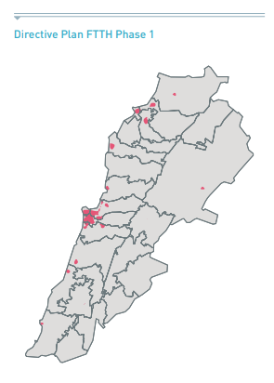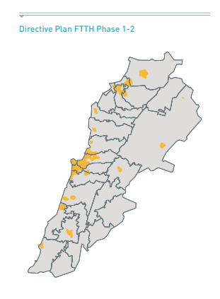
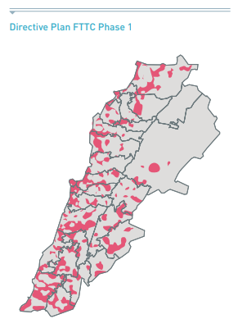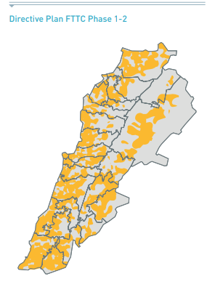
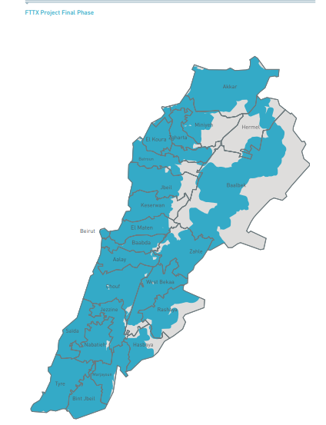
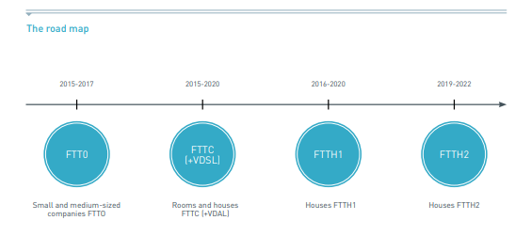

THE MOBILE NETWORK: THE TRANSITION FROM THE THIRD GENERATION (3G) TO THE FOURTH GENERATION (4G ADVANCED)
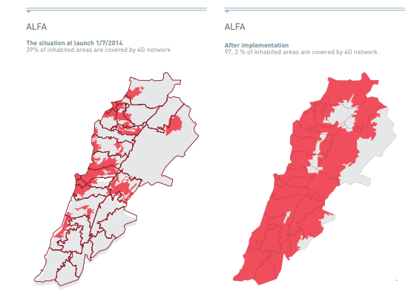
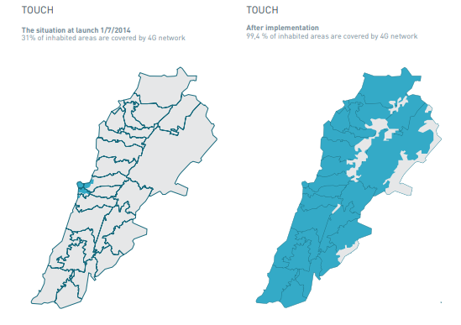

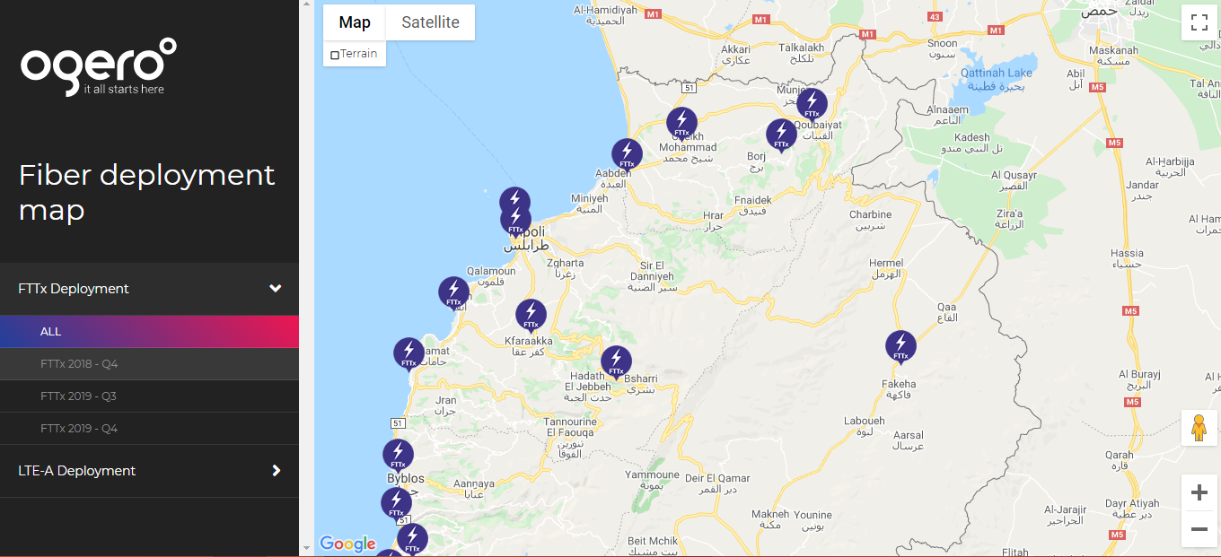
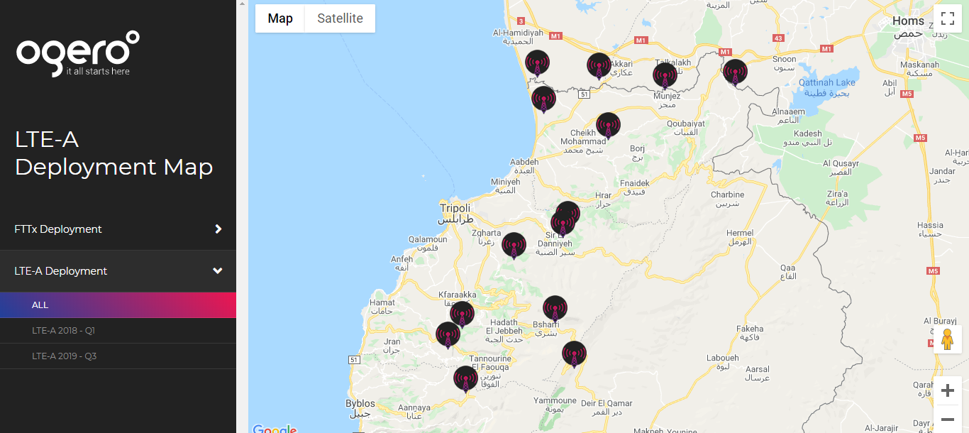
- Country profile
  - Country Rank
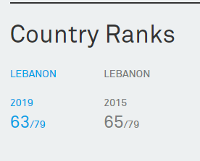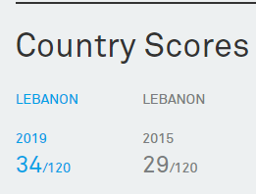

  - Strengths
Lebanon improved its ranking from 66th to 63th in GCI 2019.
Lebanon has performed well in mobile broadband penetration, scoring 7. Both smartphone penetration and mobile broadband affordability have improved. Internet usage and computer usage reached new highs this year. However, Lebanon is still behind in advanced ICT.
Less than 10% of mobile users in Lebanon are able to use 4G/LTE connections. Moreover, 3G coverage is still poor in several areas. Given that the infrastructure is already in place, Lebanon should focus on installing more new sites and expanding their coverage to all Lebanese territories.
  - Opportunities
The Lebanon government unveiled the five-year plan Telecom 2020 to revamp Lebanon’s telecoms infrastructure and guarantee fiber optic connections for Internet users across the country by 2020.
The first trial of 5G technology in Lebanon demonstrated the capabilities of this advanced technology live on the ground. They achieved impressive results, achieving download speeds of 25 Gbps. The demonstration in a live environment was an important step toward demonstrating the potential of 5G as market ready and to examine how the boundaries of telecommunications can be pushed so that 5G can meet the expectations and needs of its users. 5G technology is expected to deliver better, faster mobile broadband for consumers and enable video everywhere. It will revolutionize lives, economies, and society, and bring us not only changes in mobile communications, but also to lifestyles. It will drive economic enhancement and support a wide range of innovative new services across different industries.
  - The Four Technology Enablers
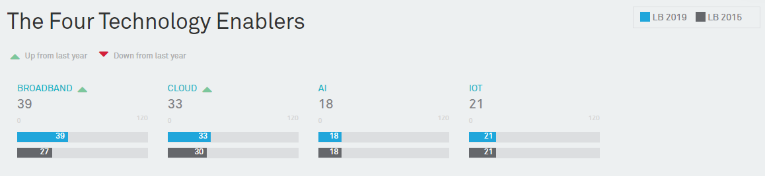

  - The four pillars
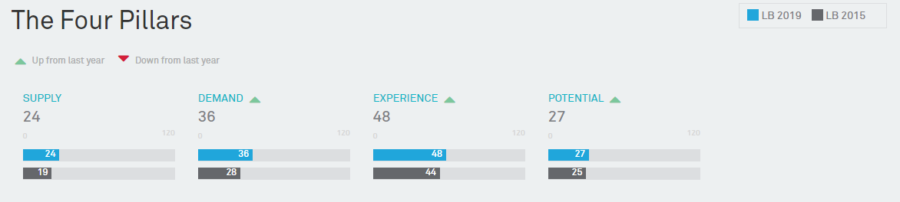
  - The 40 Indicators
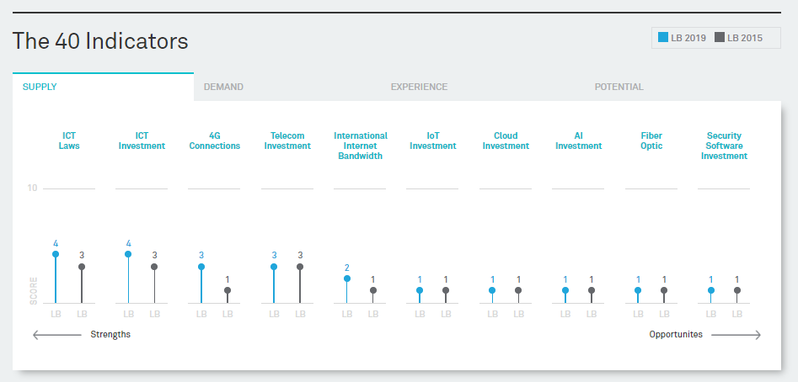
IOF: Internet of things
AI: Artificial intelligence

https://www.submarinecablemap.com/
https://en.wikipedia.org/wiki/Telecommunications_in_Lebanon
https://www.ogero.gov.lb/Maps/?id=1
https://www.huawei.com/minisite/gci/en/country-profile-lb.html#lb2015

