**Electrolysis of water – Test 1**



**Electrolysis operation method:**

1- Ensure all sanitary connections

2- Fill the first tank with distilled water

3- Fill the second tank with KOH mixture with pH = 13.47

4- Ensure that all electrical connections are made, with no electricity connected to the device

5- Filling the device completely with nitrogen gas, starting with the entry of nitrogen gas at the electrodes and its exit from the hydrogen and oxygen vents, passing through the condensate

6- Operation of the distilled water pump

7- Operation of the KOH mixture pump

8- Connect electricity (continuous power) to the device

9- Wait a while and then start collecting the hydrogen and oxygen gases produced separately by connecting the outlets to specific tanks or connecting them directly to the burner.

**Timing – Test 1:**

The test time for the device will be a full hour (60 minutes).

**Ingredients used in this test:**

Distilled water (V=50L)

KOH solution* (m= 1.34 Kg, V=50 L, pH= 13.67)

Electricity (12 V, 225 A)

**Desired results of this test:**

Volume of H2 gas evolved = 1.138 L/min = 68.28 L/hr

Volume of O2 gas evolved = 0.568 L/min = 34.08 L/hr

**Experiment time table – test 1:**

|  |  |  |  |  |  |  |  |
| --- | --- | --- | --- | --- | --- | --- | --- |
| Time (Δt=10 min) | KOH vol. (L) | H2O vol. (L) | Temp. (˚C) | Voltage (V) | Amperage (A) | H2 vol. gas (L) | O2 vol. gas (L) |
| t0= 0 min |  |  |  |  |  |  |  |
| t1= 10 min |  |  |  |  |  |  |  |
| t2= 20 min |  |  |  |  |  |  |  |
| t3 = 30 min |  |  |  |  |  |  |  |
| t4 = 40 min |  |  |  |  |  |  |  |
| t5 = 50 min |  |  |  |  |  |  |  |
| t6 = 60 min |  |  |  |  |  |  |  |

**Results:**

Remaining amount of water:

Remaining amount of KOH:

The final amount of H2 produced:

The final amount of O2 produced:

**Notes related to:**

* Connection status:
* Device status:
* Leaks:

**Other notes:**

__________________________________________

***\*KOH solution details:***

We have: 4 electrodes (2cm) → 166.6 x 4 = 666.4 gr

2 electrodes (4cm) → 333.3 x 2 = 666.6 gr

Total mass of KOH = 1333 gr = 1.34 Kg

Purety:

n = m/M = 1333/ 56.11 = 23.757 mol

C = n/V = 23.757/ 50 = 0.475 mol.L-1= 0.475 M

pOH = - log [OH-] = - log (-0.475) = 0.323

pH + pOH = 14 → pH = 14 - pOH = 14 – 0.323 =13.67

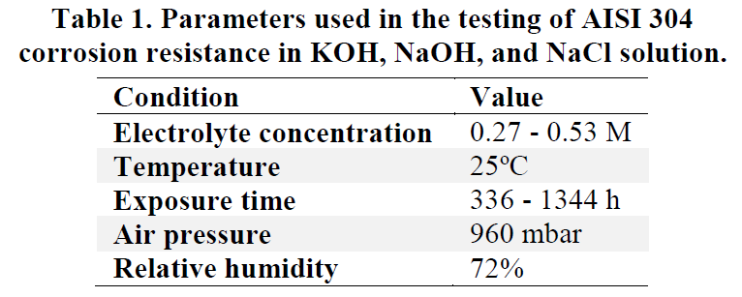

The concentration of KOH (0.48 M) is the acceptable concentration of the electrolyte, according to the given table.

__________________________________________