Fuel Cell

Author: Mariam El Rez
Editor: Samir Mourad

Last update: 13 October 2021

CONTENTS
1. Type of fuel cell 5
2. Components of fuel cell 8
3. How Fuel Cells Work 13
3.1) Parts of a fuel cell 16
3.1.1) Membrane Electrode Assembly 16
3.1.2) Hardware 17
3.2) Fuel cell systems 18
3.2.1) Fuel Cell Stack 18
3.2.2) Fuel Processor 18
3.2.3) Power Conditioners 18
3.2.4) Air Compressors 19
3.2.5) Humidifiers 19
4. Cell structure 19
5. Analysis of quantities 21
5.1) Fluidic quantities 21
5.2) Thermal quantities 23
5.3) Electric dynamic 24
6. Parametric influence 25
6.1) In the canals 25
6.2) In the catalytic layer 25
6.3) In the membrane 26
7. Comparison of Fuel Cell technologies 27
8. Production process of PEM fuel cell components 27
9. Overview of PEM fuel cell components 28
10. Thermal Engineering Performance Evaluation of a Polymer Electrolyte Membrane Fuel Cell Stack at Partial Load 30
10.1) Thermal Engineering Analysis 30
10.2) Experimental Method 32
10.3) Cooling Performance 38
10.4) Conclusions 38
11. Consideration for Fuel Cell Design 39
11.1) Fuel Cell Stack Size 39
11.2) Number of Cells 40
11.3) Stack Configuration 41
12. Polymer Electrolyte Membrane Fuel Cells (PEMFCs) 43
12.1) Basic stationary fuel cell calculations. 44
12.2) Fuel Cell Reversible and Net Output Voltage 46
13. Model creation of PEM fuel cell 48
13.1) Material and assembly (exp) 49
13.2) Experimental set-up and procedure ¹⁴ 51
14. Study of PEM Fuel Cell End Plate Design by Structural Analysis Based on Contact Pressure 52
14.1) Introduction 52
14.2) Description of Geometry 53
14.3) Boundary condition 55
15. Components in a single cell 56
16. Fuel cell stack 57
16.1) Add cell to the stack 57
16.2) Working prototype 66
17. Fuel Cell Materials 68
17.1) Electrolyte Layer 68
Cation Exchange Membrane Comparison Chart 69
17.2) Fuel Cell Electrode Layers - PEMFC catalysts 69
17.3) PEMFC gas diffusion layers 69
18. Constructing the Fuel Cell Bipolar Plates, Gaskets, End Plates, and Current Collectors 70
18.1) Bipolar plate design 70
18.2) Gasket selection 72
18.3) End plates 72
References 76

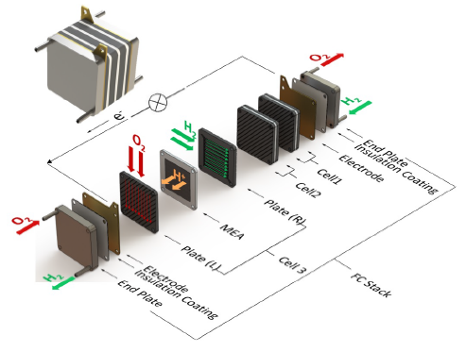
Schematics of a fuel cell stack operation and components

An electric generator:
- The fuel cell transforms chemical energy into electrical energy;
- We have a fuel and an oxidizer as in a heat engine;
- Electric power is produced directly without an alternator.

- Type of fuel cell
There are currently 6 types of fuel cell:

• AFC (Alkaline fuel Cell),
• PEMFC (Polymer Exchange Membran Fuel Cell),

• DMFC (Direct Methanol Fuel Cell),
• PAFC (Phosphoric Acid Fuel Cell),

• MCFC (Molten carbonate Fuel Cell),
• SOFC (Solid Oxid Fuel Cell).

- PEMFC
- Uses H₂ as fuel (sometimes CH₃OH)
- A polymer membrane
- Works at a low temperature (≈ 60˚C)
- Starts quickly
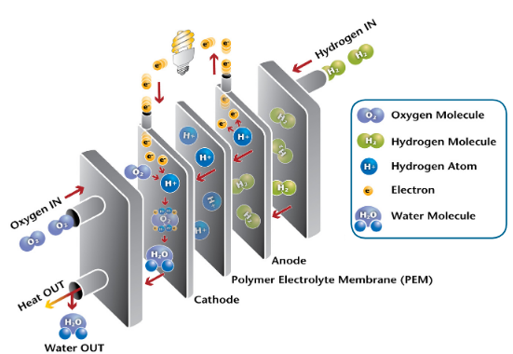

In a few words...
- 2H₂ + O₂ → 2H₂O ;
- During the reaction 4 electrons are exchanged;
- The theoretical open circuit potential is of the order of 1.2 V per cell.

Boundary conditions and assembly (assumption: all cells identical)
- The temperatures of the cooling circuit on the left and on the right of the cell will be considered as a single distribution;
- The voltage of the fuel cell will be the number of cells times the calculated voltage in a cell.
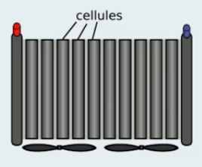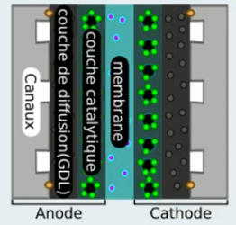
Cells Layers

Balance sheet and eponymy
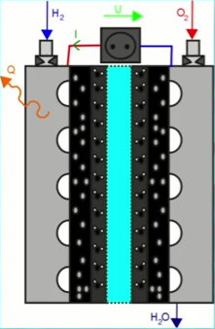
Entries
- H₂ : pressure (+H₂O)
- O₂ : pressure (+H₂O)
- I : current consume by the load

Exit
- U : Voltage delivered by the battery
- Q : Heat delivered by the battery
- H2O : Amount of water delivered by the battery ( N_{H2O} = $\frac{2}{FI}$ )

Losses
- U = E – V activ – V resist – V conc
- The loss
  - Losses by activation;
  - Ohmic losses;
  - Losses by concentration.
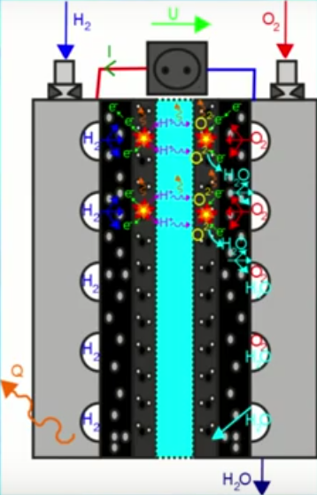

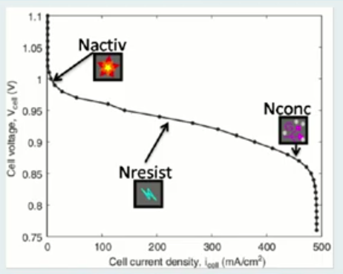
Polarization curve

- Components of fuel cell
A typical PEM element consists of several components.
First, there is a current collector.
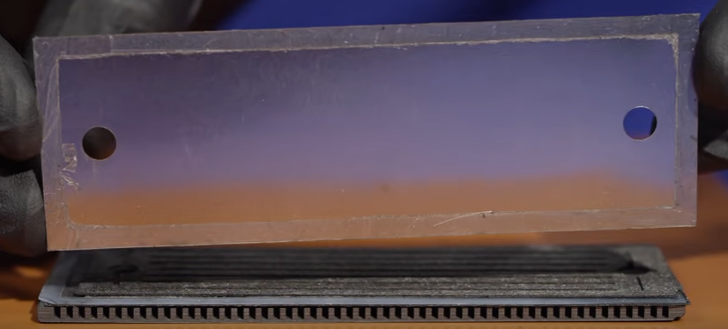

Next, gas diffusion layer for anode (the gas diffusion layer consists of carbon fibers)
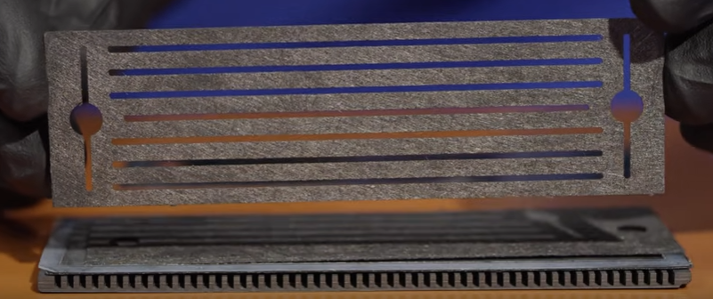

Then the membrane electrode assembly, which consists of anode and cathode catalysts deposited onto a nafion membrane (the electron microscopy shows that the cathode catalyst layer is much thicker than anode).
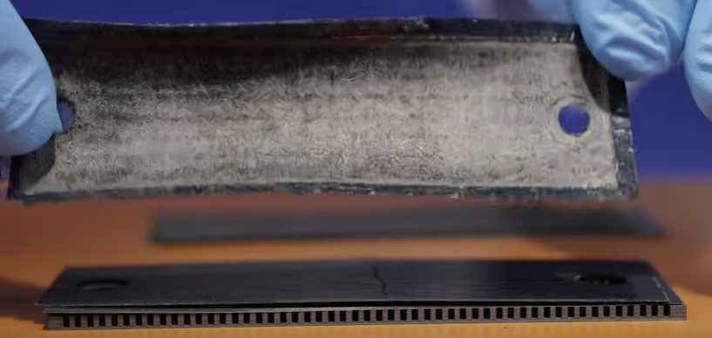
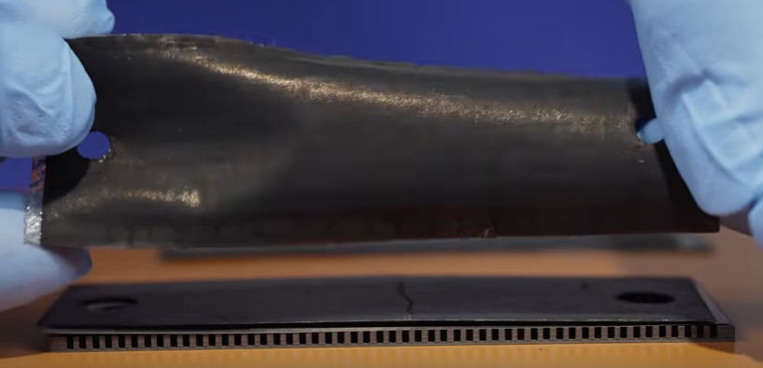

Next , the cathode gas diffusion layer
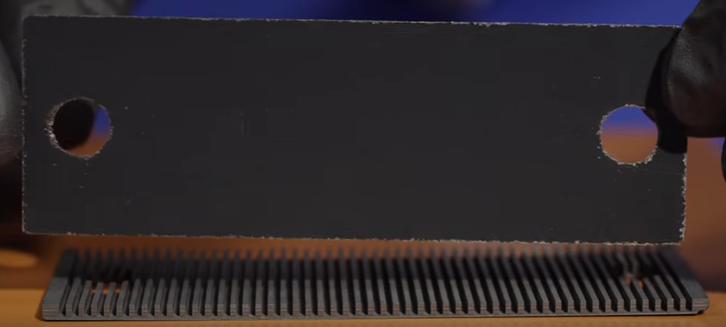

A perforated metal plate
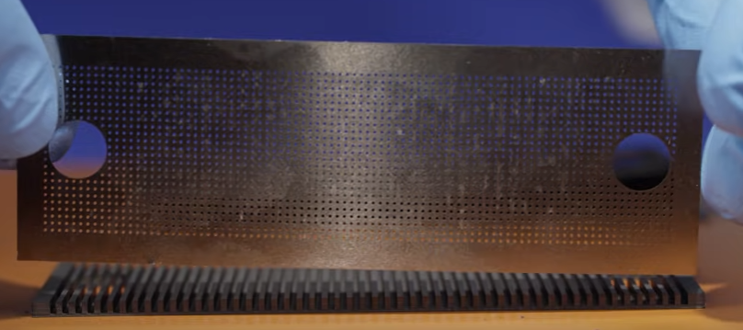

And finally the bipolar plate, which acts as a current collector and distributes air in the element.
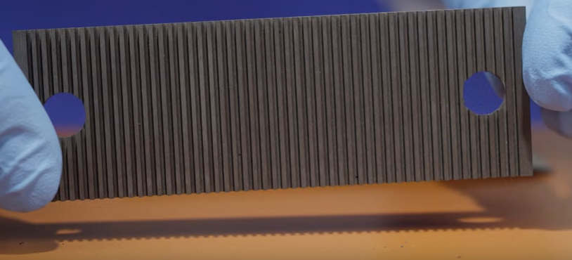

To create a working fuel cell stack, several single cells are connected in series.
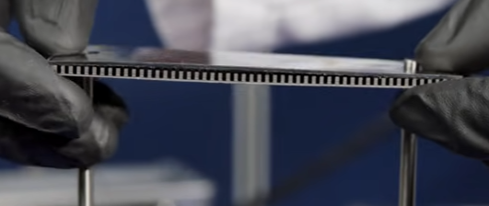
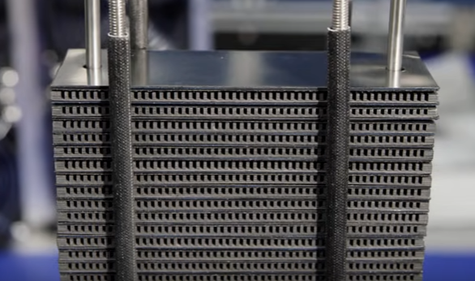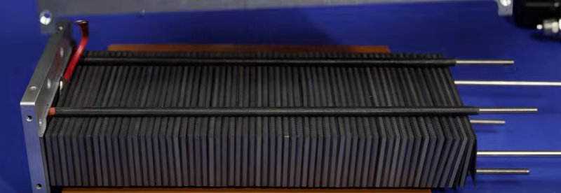
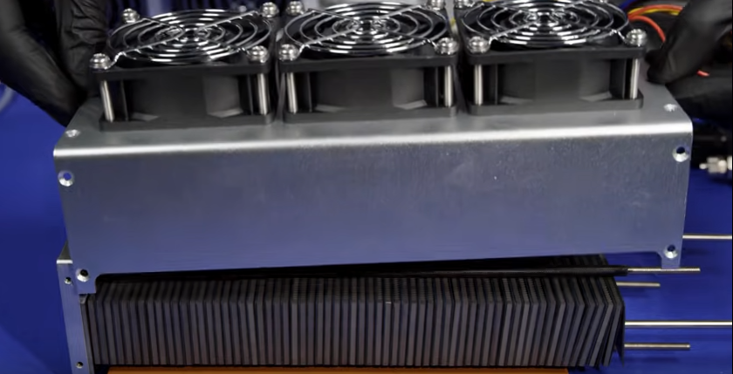

- How Fuel Cells Work
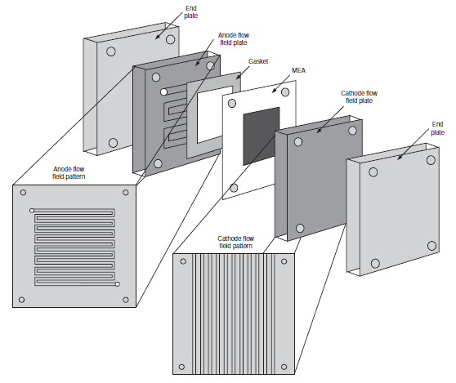
An exploded view of a fuel cell stack

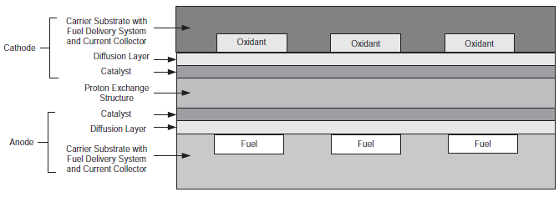
Basic micro fuel cell based upon traditional fuel cell design ⁵
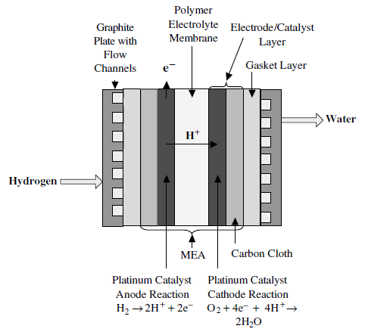
Generalized schematic of a single fuel cell

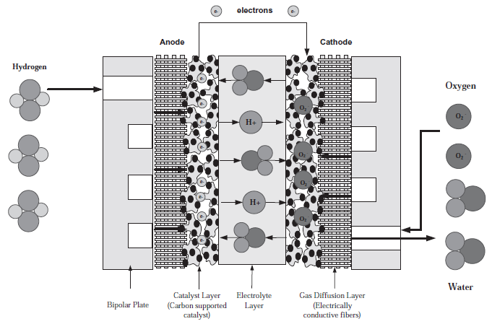
Schematic of a PEM fuel cell stack ⁵
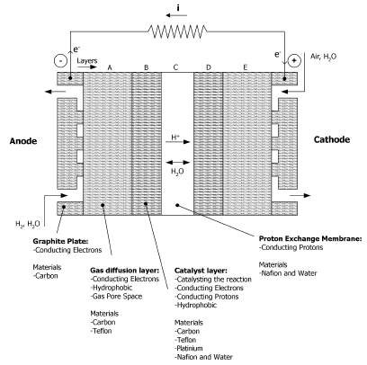
A cross section of the PEM fuel cell. The unit cell is made of 7 layers which are made of different compositions of material providing the layers with different properties
Fuel cells work like batteries, but they do not run down or need recharging. They produce electricity and heat as long as fuel is supplied. A fuel cell consists of two electrodes—a negative electrode (or anode) and a positive electrode (or cathode)—sandwiched around an electrolyte. A fuel, such as hydrogen, is fed to the anode, and air is fed to the cathode. In a hydrogen fuel cell, a catalyst at the anode separates hydrogen molecules into protons and electrons, which take different paths to the cathode. The electrons go through an external circuit, creating a flow of electricity. The protons migrate through the electrolyte to the cathode, where they unite with oxygen and the electrons to produce water and heat. Learn more about:
- Parts of a fuel cell
- Fuel cell systems
- Types of fuel cells.
  - Parts of a fuel cell
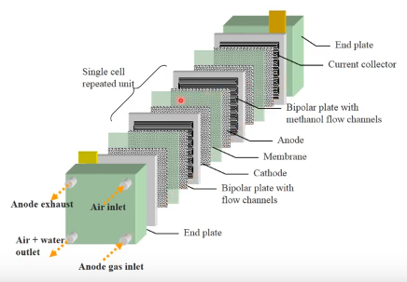
PEMFC – flowing path of fuel and air
Polymer electrolyte membrane (PEM) fuel cells are the current focus of research for fuel cell vehicle applications. PEM fuel cells are made from several layers of different materials. The main parts of a PEM fuel cell are described below.
The heart of a PEM fuel cell is the membrane electrode assembly (MEA), which includes the membrane, the catalyst layers, and gas diffusion layers (GDLs).
Hardware components used to incorporate an MEA into a fuel cell include gaskets, which provide a seal around the MEA to prevent leakage of gases, and bipolar plates, which are used to assemble individual PEM fuel cells into a fuel cell stack and provide channels for the gaseous fuel and air.

Membrane Electrode Assembly
The membrane, catalyst layers (anode and cathode), and diffusion media together form the membrane electrode assembly (MEA) of a PEM fuel cell.
  - Polymer Electrolyte Membrane
The polymer electrolyte membrane, or PEM (also called a proton exchange membrane)—a specially treated material that looks something like ordinary kitchen plastic wrap—conducts only positively charged ions and blocks the electrons. The PEM is the key to the fuel cell technology; it must permit only the necessary ions to pass between the anode and cathode. Other substances passing through the electrolyte would disrupt the chemical reaction. For transportation applications, the membrane is very thin—in some cases under 20 microns.
  - Catalyst Layers
A layer of catalyst is added on both sides of the membrane—the anode layer on one side and the cathode layer on the other. Conventional catalyst layers include nanometer-sized particles of platinum dispersed on a high-surface-area carbon support. This supported platinum catalyst is mixed with an ion-conducting polymer (ionomer) and sandwiched between the membrane and the GDLs. On the anode side, the platinum catalyst enables hydrogen molecules to be split into protons and electrons. On the cathode side, the platinum catalyst enables oxygen reduction by reacting with the protons generated by the anode, producing water. The ionomer mixed into the catalyst layers allows the protons to travel through these layers.
  - Gas Diffusion Layers
The GDLs sit outside the catalyst layers and facilitate transport of reactants into the catalyst layer, as well as removal of product water. Each GDL is typically composed of a sheet of carbon paper in which the carbon fibers are partially coated with polytetrafluoroethylene (PTFE). Gases diffuse rapidly through the pores in the GDL. These pores are kept open by the hydrophobic PTFE, which prevents excessive water buildup. In many cases, the inner surface of the GDL is coated with a thin layer of high-surface-area carbon mixed with PTFE, called the microporous layer. The microporous layer can help adjust the balance between water retention (needed to maintain membrane conductivity) and water release (needed to keep the pores open so hydrogen and oxygen can diffuse into the electrodes).

Hardware
The MEA is the part of the fuel cell where power is produced, but hardware components are required to enable effective MEA operation.
- Bipolar Plates
Each individual MEA produces less than 1 V under typical operating conditions, but most applications require higher voltages. Therefore, multiple MEAs are usually connected in series by stacking them on top of each other to provide a usable output voltage. Each cell in the stack is sandwiched between two bipolar plates to separate it from neighboring cells. These plates, which may be made of metal, carbon, or composites, provide electrical conduction between cells, as well as providing physical strength to the stack. The surfaces of the plates typically contain a “flow field,” which is a set of channels machined or stamped into the plate to allow gases to flow over the MEA. Additional channels inside each plate may be used to circulate a liquid coolant.
- Gaskets
Each MEA in a fuel cell stack is sandwiched between two bipolar plates, but gaskets must be added around the edges of the MEA to make a gas-tight seal. These gaskets are usually made of a rubbery polymer.

  - Fuel cell systems
The design of fuel cell systems is complex and can vary significantly depending upon fuel cell type and application. However, several basic components are found in many fuel cell systems:
- Fuel cell stack
- Fuel processor
- Power conditioners
- Air compressors
- Humidifiers.

Fuel Cell Stack
The fuel cell stack is the heart of a fuel cell power system. It generates electricity in the form of direct current (DC) from electrochemical reactions that take place in the fuel cell. A single fuel cell produces less than 1 V, which is insufficient for most applications. Therefore, individual fuel cells are typically combined in series into a fuel cell stack. A typical fuel cell stack may consist of hundreds of fuel cells. The amount of power produced by a fuel cell depends upon several factors, such as fuel cell type, cell size, the temperature at which it operates, and the pressure of the gases supplied to the cell.

    - Fuel Processor

The fuel processor converts fuel into a form usable by the fuel cell. Depending on the fuel and type of fuel cell, the fuel processor can be a simple sorbent bed to remove impurities, or a combination of multiple reactors and sorbents.

Power Conditioners
Power conditioning includes controlling current (amperes), voltage, frequency, and other characteristics of the electrical current to meet the needs of the application. Fuel cells produce electricity in the form of direct current (DC). In a DC circuit, electrons flow in only one direction. The electricity in your home and workplace is in the form of alternating current (AC), which flows in both directions on alternating cycles. If the fuel cell is used to power equipment that uses AC, the direct current will have to be converted to alternating current.
Both AC and DC power must be conditioned. Current inverters and conditioners adapt the electrical current from the fuel cell to suit the electrical needs of the application, whether it is a simple electrical motor or a complex utility power grid. Conversion and conditioning reduce system efficiency only slightly, around 2%–6%.

Air Compressors
Fuel cell performance improves as the pressure of the reactant gases increases; therefore many fuel cell systems include an air compressor, which raises the pressure of the inlet air to 2–4 times the ambient atmospheric pressure. For transportation applications, air compressors should have an efficiency of at least 75%. In some cases, an expander is also included to recover power from the high pressure exhaust gases. Expander efficiency should be at least 80%.

Humidifiers
The polymer electrolyte membrane at the heart of a PEM fuel cell does not work well when dry, so many fuel cell systems include a humidifier for the inlet air. Humidifiers usually consist of a thin membrane, which may be made of the same material as the PEM. By flowing dry inlet air on one side of the humidifier and wet exhaust air on the other side, the water produced by the fuel cell may be recycled to keep the PEM well hydrated.

- Cell structure

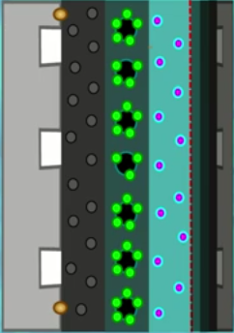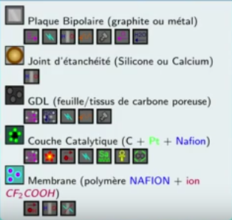
We have here a half cell to represent is in a symmetrical structure although their function would be different so on each side we will have what is called a bipolar plate, it is a plate which must lead, which must direct the gases in the channels. It must conduct electricity to collect electrons. It must make it possible to separate the hydrogen and the oxygen in order to avoid a possible explosion, it must allow the heat to be evacuated, it provides the mechanical support of the cell and it possibly makes it possible to evacuate gases, in particular from the gas. air which mainly exceeds nitrogen and water which is produced by the chemical reaction.

Then we have gaskets, gaskets are usually calcium or silicone, they are there only to avoid queues and hydrogen leakage is therefore a fuel cell explosion.

Then in the GDL of a gas diffuses the best therefore the diffusion layer which is generally a sheet or a carbon fabric for them which therefore catches the role of diffusing the gases on the whole of the catalytic layer to evacuate the water produced by the reaction. It must also conduct electricity must be made of carbon conduct heat to evacuate it and it provides a certain mechanical support which prevents the shape of the channels from destroying the membrane.

Then the catalytic layer which is formed of carbon on which their effects are the smaller platinum particles possibly mixing with a solution of Nafion. Nafion which is the solution which is used to produce the membrane so this catalytic layer and the sludge functions, it must allow the diffusion of gases that it can react, it must catalyze the reaction must allow proton to pass into the membrane. It must conduct electricity to the layers of the diffusions, it must have as large a surface area as possible to increase the power of our fuel cell at an equivalent volume, it must have the longest possible lifespan and we strive to make sure that it resists any form of imprisonment like carbon monoxide which can ruin fuel cells pretty fast.

Finally, we have the membrane which is made of a Nafion polymer containing the carboxylic ions with the same fluorine which has the property not to conduct electricity but to conduct protons which makes the reaction possible.
It must also ensure tightness so as to prevent hydrogen and oxygen from this mixture directly and causing an explosion.
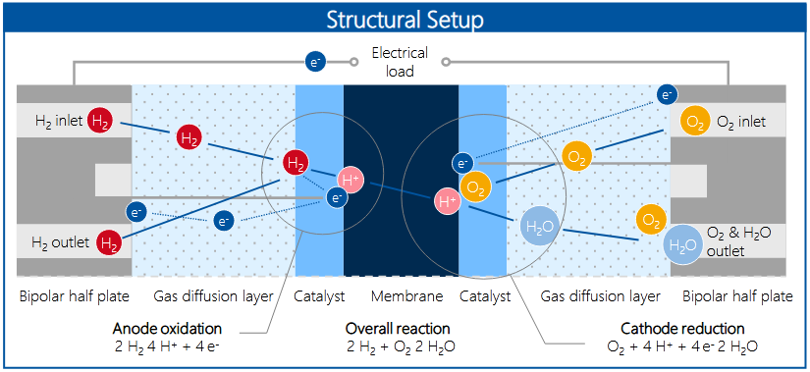

- Analysis of quantities
  - Fluidic quantities
    - In the canals
Fluidic quantities
- The gases have a pressure of 1 to 8 bars
- Hydrogen flow rate: 0.1e-3 mol / sec to 1000 mol / sec
- Air flow: 1E-3 to 1000 mol / sec.

Settings
- Channel length: 1 - 8 m
- Channel diameter: 0.1 to 5 mm
- Parallel number: 1 – 8
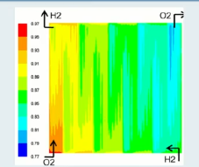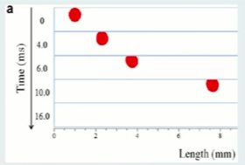
Pressure distributions (O₂) Dynamic

    - In the GDL

Sizes
- Pressure 1 - 2 bar
- Flow 0.1 - 1E-3 mol / sec

Setting
- Diffusion coefficient 2.5 - 9E-5
- Thickness of the scattering layer 0.2 - 0.6 mm

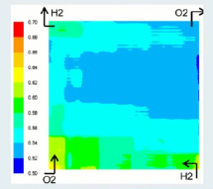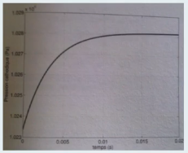
Distributions Dynamic

    - In the membrane
Sizes
- Water concentration: 0.001 to 0.2 mol / m³
Setting
- Thickness 150 - 400 μm
But we make membranes thinner and thinner as we can improve their existence in order to reduce losses by Joule effect
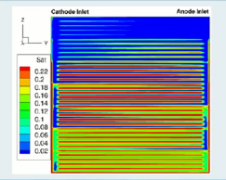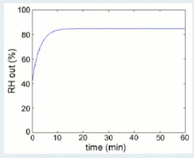
Distributions (liquid saturation) Dynamic

  - Thermal quantities
    - In the electrode
Size
- Temperature: from 290 to 333 K (from 20˚C to 60˚C)

Settings
- Thermal conduction 175 W/K
- Thermal capacity 24 J/K
- In a commercial pile such as the harness ball that it takes 1 sec to cancel 7 K with cooling system
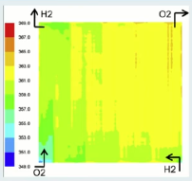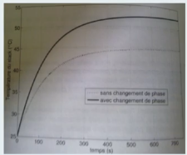
Distributions Dynamic

    - In the GDL membrane / catalytic layer assembly
Size
- Temperature
Settings
- Thermal capacity 4 J/k
- Conduction 11 w/k
- 0.3 sec/k for temperature stabilization

  - Electric dynamic
    - In the channels and the diffusion layer
Sizes
- Current: 0 - 50 A
- Voltage of a cell: 0.5 - 1.3 V
Setting
- Resistance of a cell: 15 μΩ
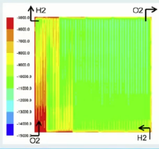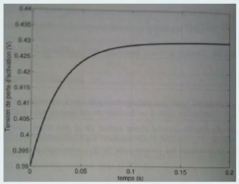
Distributions Dynamic

    - In the catalytic layer
Sizes
- Voltage of one cell 0.5 - 1.3 v
- Current 0 - 50 A
Setting
- Double layer capacitance 2 - 3 F

    - In the membrane
Sizes
- Voltage 0.5 - 1.3 v
- Current 0 - 50 A
Setting
- Resistance 0.25 – 3 Ω
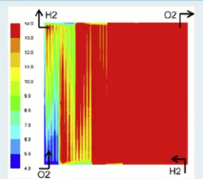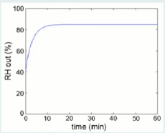
Distributions (water content) Dynamic

- Parametric influence
  - In the canals
A change in pressure has very little influence on heat and vice versa, and the device has relatively little input between heat and electric current and between electric current and movement. on the other hand, one can have an acceleration of 1.5 mm/sec per additional year pair in a conventional pile. Same in the diffusion layer.
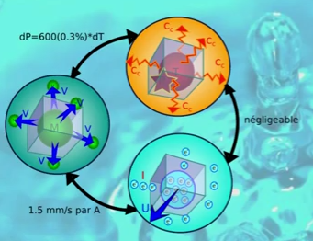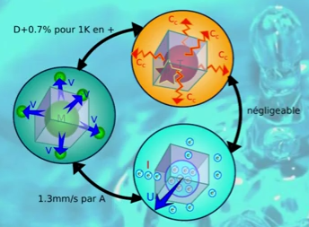
Same in the diffusion layer In the diffusion layer

  - In the catalytic layer
In the catalytic layer, 30% variation in attention for 100% variation in temperature so we still had an influence which can be significant between the temperature and the voltage which is linked to the losses. function the temperature we have not the same allowed the same result with the berne law is not to mention the effect of the temperature under the fuel cell the voltage little increased by 25% for an oxygen concentration 10% higher therefore also for strong currents. if we have an agreement between the oxygen concentration which decreases we have a significant loss of tension a temperature increase of 10 degrees in the membrane can multiply its electrical resistance by 3 and the influence of water it is also very important therefore we can divide by three the resistance for a concentration of other two times higher and when we have 75% we can still reduce the resistance by 30% so water is very important in the limbs there.

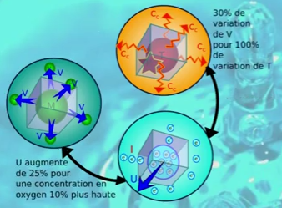

  - In the membrane
An increase in temperature of 10 degrees in the membrane can multiply its electrical resistance by three and the influence of water is also very important so we can divide by three the resistance for a concentration of other two times higher and when we at 75% we can further reduce the resistance by 30% so water is very important in the membrane there.

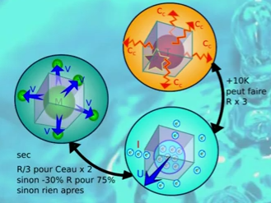

- Comparison of Fuel Cell technologies
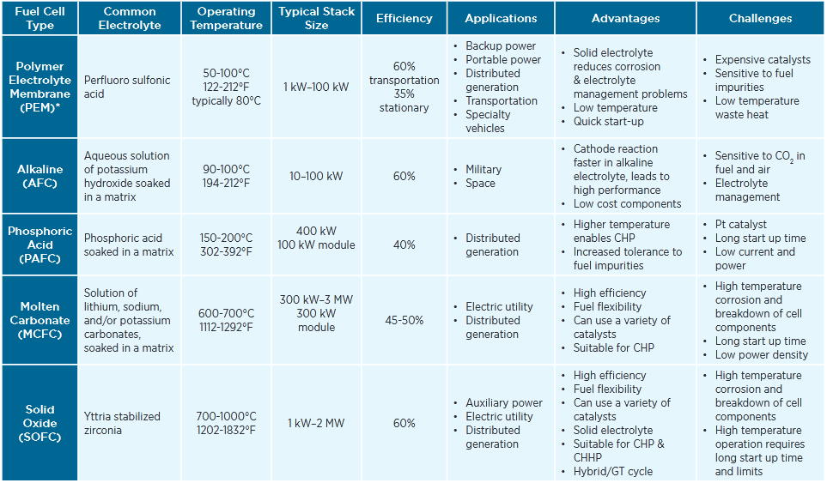

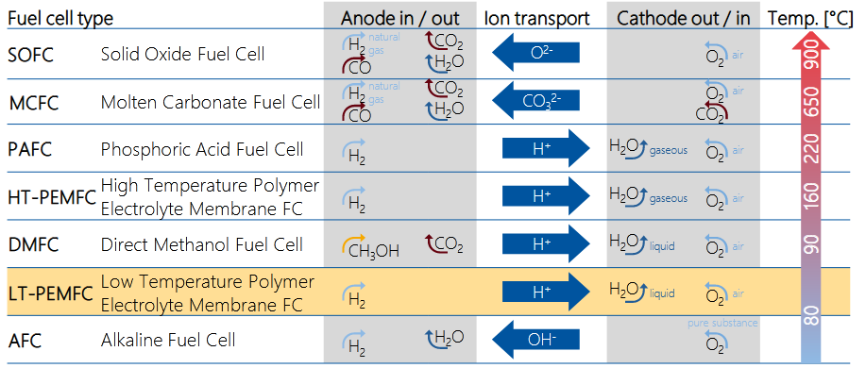

- Production process of PEM fuel cell components

● Due to the small production volumes of fuel cells, there is currently no
generally valid process chain for the series production of PEM fuel cell
components.
● Production of a PEM fuel cell system can be divided into three superordinate steps: component production, stack production and system production.
● This brochure presents the process steps that constitute the current state of the art in the production of PEM fuel cell components.
● Production of the fuel cell stack and system is explained in more detail in a separate brochure entitled "Production of Fuel Cell Systems”.

Component Production:
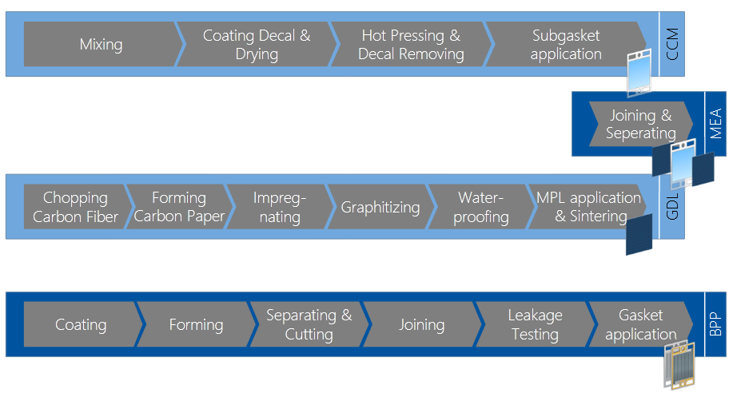

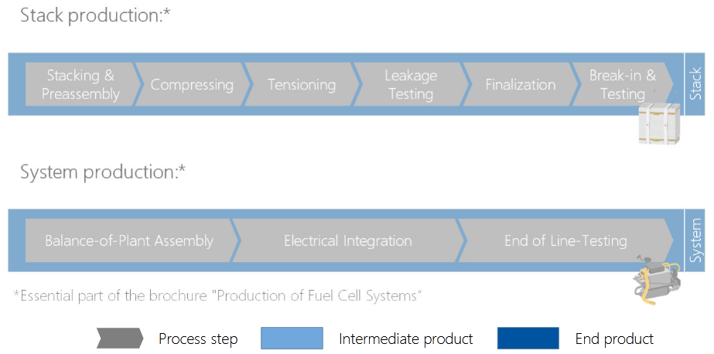

- Overview of PEM fuel cell components
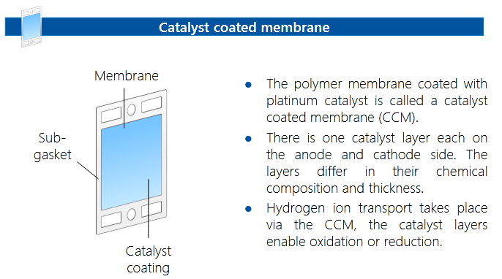

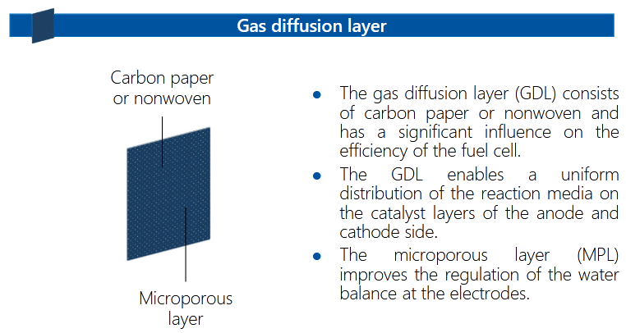

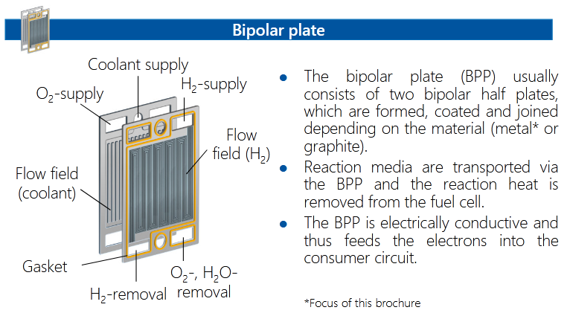

- Thermal Engineering Performance Evaluation of a Polymer Electrolyte Membrane Fuel Cell Stack at Partial Load
  - Thermal Engineering Analysis
Stack heat generation is a theoretical heat quantity based on the conversion efficiency of the fuel cells. The theoretical maximum voltage for a single cell based on the Higher Heating Value of hydrogen is 1.482V when the products are all in liquid state. The stack for this work has a design rating of 45% efficiency at full load, and the theoretical heat generation for the stack can be estimated using Equation (1).

In equation (1), I represent the stack current in Ampere (A) and n_{cell} is the number of cells of the stack.

Equations 2 to 14 are applied accordingly for the analysis where the scope covers the relation of stack thermal conditions to output power, active-to-passive cooling contributions, and cooling system effectiveness.

The electrical power output in Watts,
For a single cell, the cell efficiency
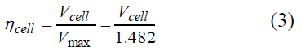
Thus, the stack efficiency was evaluated using
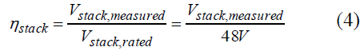
The cooling mechanism of the fuel cell stack is categorized as active cooling and passive cooling. Active cooling is achieved by circulating cooling water internally and using an air-cooled heat exchanger (radiator) to dissipate the heat to the surrounding. Active cooling theoretically contributes at least 90% [12] of the total cooling effect. Passive cooling plays only a minor role, but the effects are more significant as the stack temperature increases.

The calculation of active cooling rate is based on the energy property changes of the cooling water as it carries away the heat from the fuel cell stack.

Cooling water energy changes,
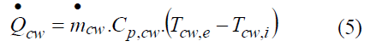
Air energy changes,
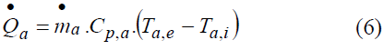
The subscripts cw and a are for cooling water and air respectively, while subscripts e is for the exit state and i for the inlet state. The net heat in the stack related to the temperature difference over a certain time period,
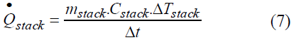
Passive cooling over the exposed stack surfaces consists of free (natural) convection by the ambient surroundings as well as heat transfer by radiation. The free convection cooling effect is based on

In this case, the surface areas involved are two vertical flat side surfaces, two vertical flat end surfaces, and one horizontal surface with heated surface facing upward. The Nusselt number correlations were calculated for each orientation and the respective free convection coefficient, h, and surface cooling is calculated.

Cooling by radiation heat transfer is expressed by
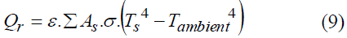

σ is the Stefan-Boltzmann constant, equals to 5.67 x 10-8, and ε is the surface emissivity.

Thus, the passive cooling rate is the summation of free convection and radiative cooling over the stack surfaces,

The total cooling effect is the summation of active and passive cooling rates.

From equations (7) and (11), the total stack thermal power can be calculated.

For the radiator, the analysis on the radiator effectiveness is evaluated by,

The maximum possible cooling rate in a heat exchanger is

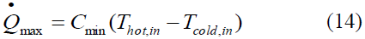

where C_{min} is the smaller of 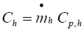 and 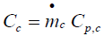.

  - Experimental Method
The experiment was conducted using a PEM fuel cell system designed for Uninterrupted Power Supply (UPS). The system configuration and general specifications of the hardware are presented in Figure 1 and Table 1 respectively. The working fluids are hydrogen, reactant air, cooling water and cooling air. Table 2 summarizes the operating conditions of the experimental. The measurements were taken at 3 minutes intervals using a thermal scanner and Ktype thermocouples with data logger for local temperatures at 18 designated points of the stack, anemometer for air velocity and temperature, and a multi-meter for electrical power measurement at the resistant loader.

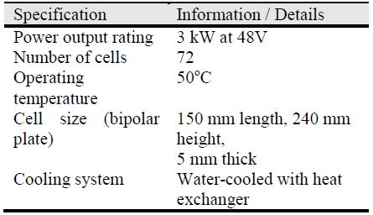
Table 1: PEM fuel cell system specifications

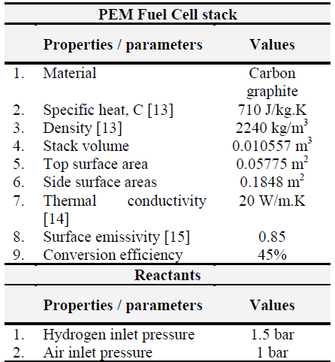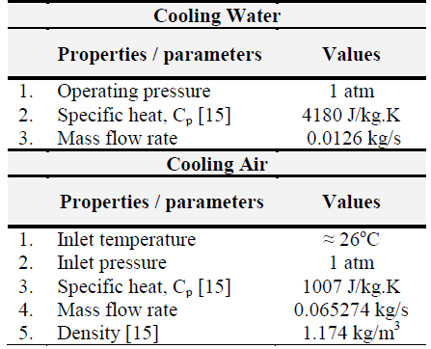
Table 2: Operating conditions

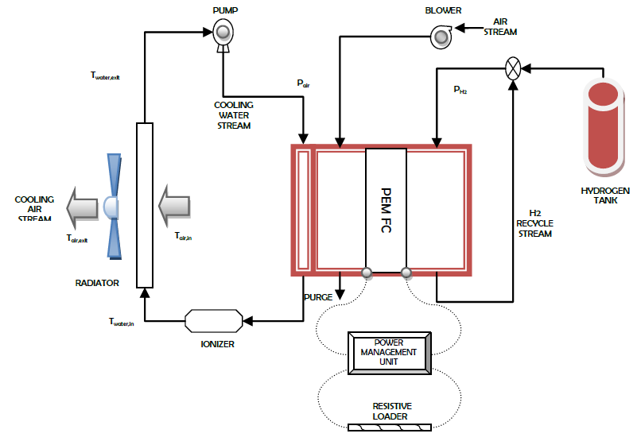
The fuel cell system schematic

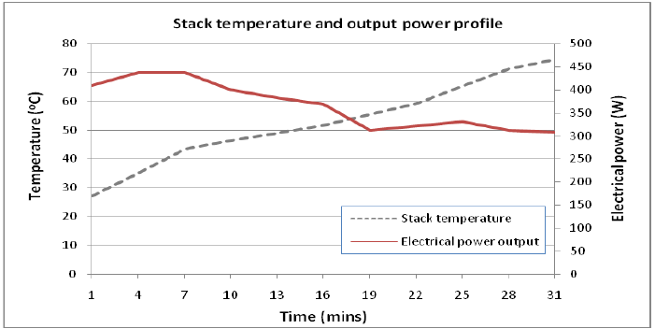
Relation of stack temperature to electrical power

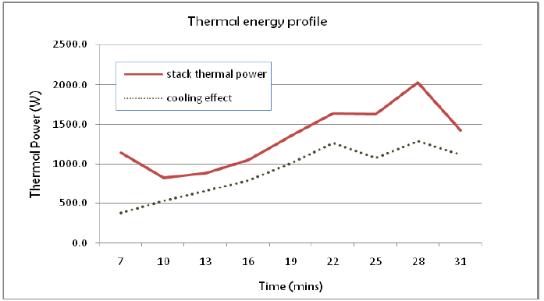
The total stack thermal energy compared to combined cooling effects

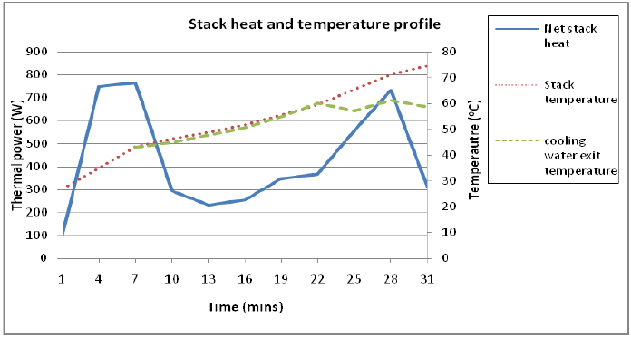
Relation of stack heat and stack-to-cooling water temperature profile

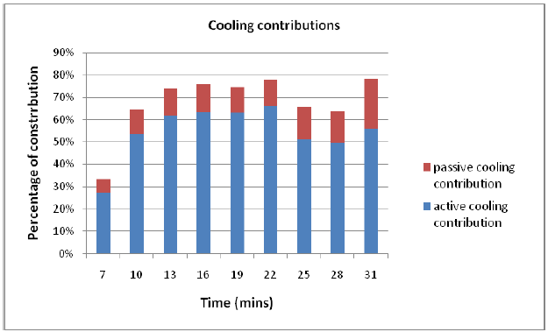
Active and passive cooling contribution percentages

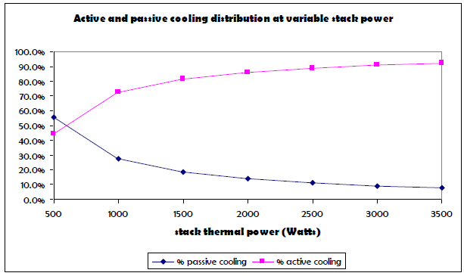
Theoretical optimum cooling contributions of passive and active cooling

  - Cooling Performance
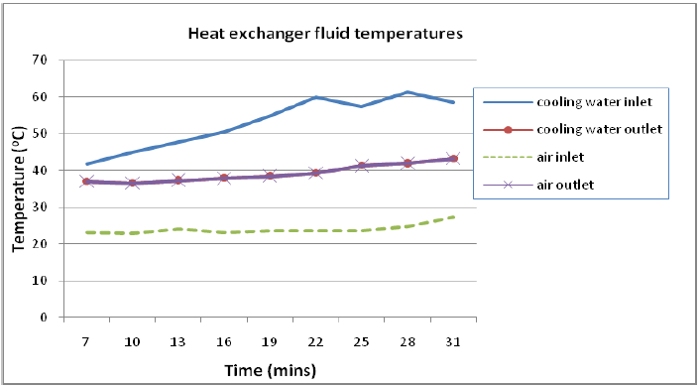
Temperature profile at heat exchanger

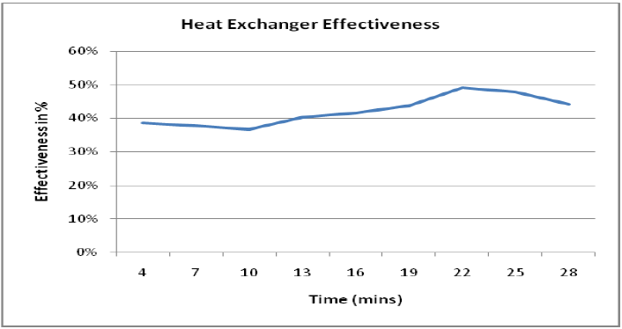
Effectiveness of the heat exchanger at steady-state

  - Conclusions
Experimental analysis of a water-cooled PEM fuel cell system shows that the stack temperature can be largely influenced by the coolant. The stack temperature increased to unacceptable levels due to the influence from the cooling water temperature. To maintain the stack at the required operating temperature below 50˚C, the generated heat needs to be adequately dissipated by an active cooling system operating higher than 90% cooling effectiveness, and the cooling water temperature at the inlet and outlets of the stack must also be controlled below 40˚C at all times. With a registered effectiveness of less than 50%, unsuitable operating conditions of the heat exchanger was identified as the main cause for the thermal problem facing the stack, especially regarding the flow rates of both fluids.

- Consideration for Fuel Cell Design
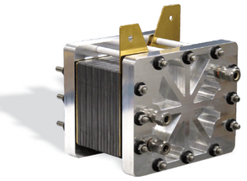
When you first consider your fuel cell stack design, you will need to calculate the following:
• Stack size
• Number of cells (MEAs / CCMs)
• Stack configuration (flow field plates, GDL, etc.)
This paragraph presents an overview of the initial considerations for fuel cell design in room-temperature fuel cells.

Fuel Cell Stack Size
The first step in engineering a fuel cell stack is to obtain the power requirements. The stack is then designed to meet those requirements, and the maximum power, voltage, and current are often known. The power output of a fuel cell stack is a product of stack voltage and current:
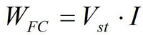 (15)

The maximum power and voltage requirements are dependent upon the application. The engineer must understand these specifications to build an appropriately-sized fuel cell stack. It is helpful to know the current and power density when designing a fuel cell stack. These are often unavailable initially but can be calculated from the desired power output, stack voltage, efficiency, and volume and weight limitations. The current is a product of the current density and the cell active area:
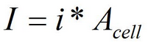 (16)
The cell potential and the current density are related by the polarization curve:
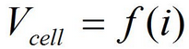 (17)

An example of a polarization curve is shown in Figure below. The polarization curve can be used to help initially design the fuel cell stack.
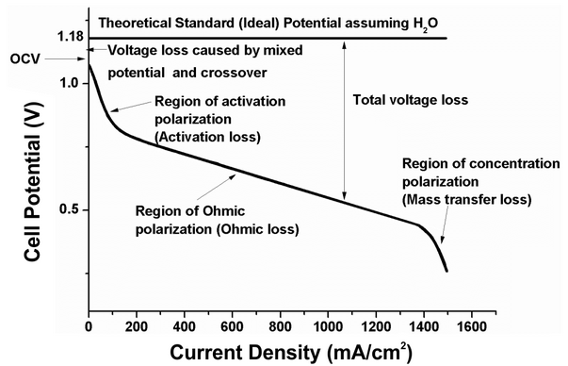

Typical polarization curve for a PEM fuel cell stack.

Most fuel cell developers use a nominal voltage of 0.6 to 0.7 V at nominal power. Fuel cell systems can be designed at nominal voltages of 0.8 V per cell or higher if the correct design, materials, operating conditions, balance-of-plant, and electronics are selected.
The actual fuel cell performance is determined by the pressure, temperature, and humidity based on the application requirements, and can often be improved (depending upon fuel cell type) by increasing the temperature, pressure, and humidity, and optimizing other important fuel cell variables. The ability to increase these variables is application-dependent because system issues, weight, and cost play important factors when optimizing certain parameters.

Number of Cells
The number of cells in the stack is often determined by the maximum voltage requirement and the desired operating voltage. The total stack potential is the sum of the stack voltages or the product of the average cell potential and number of cells in the stack:
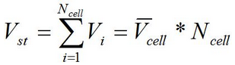 (18)

The cell area must be designed to obtain the required current for the stack. When this is multiplied by the total stack voltage, the maximum power requirement for the stack must be obtained. Most fuel cell stacks have the cells connected in series, but stacks can be designed in parallel to increase the total output current. When considering the stack design, it is preferable to not have cells with a small or very large active area because the cells can result in resistive losses. With fuel cells that have large active areas, it can be difficult to achieve uniform temperature, humidity and water management conditions.
The cell voltage and current density is the operating point at nominal power output and can be selected at any point on the polarization curve. The average voltage and corresponding current density selected can have a large impact on stack size and efficiency. A higher cell voltage means better cell efficiency, and this can result from the MEA materials, flow channel design, and optimization of system temperature, heat, humidity, pressure, and reactant flow rates. The fuel cell stack efficiency can be approximated with the following equation:
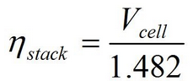 (19)

Stack Configuration
In the traditional bipolar stack design, the fuel cell stack has many cells stacked together so that the cathode of one cell is connected to the anode of the next cell. The main components of the fuel cell stack are the membrane electrode assemblies (MEAs), gaskets, bipolar plates with electrical connections and end plates. The stack is connected by bolts, rods, or other methods to clamp the cells together.
When contemplating the appropriate fuel cell design, the following should be considered:
• Fuel and oxidant should be uniformly distributed through each cell, and across their surface area.
• The temperature must be uniform throughout the stack.
• If designing a fuel cell with a polymer electrolyte, the membrane must not dry out or become flooded with water.
• The resistive losses should be kept to a minimum.
• The stack must be properly sealed to ensure no gas leakage.
• The stack must be sturdy and able to withstand the necessary environments.
The most common fuel cell configuration is shown in Figure 2. Each cell (MEA) is separated by a plate with flow fields on both sides to distribute the fuel and oxidant. The fuel cell stack end plates have only a single-sided flow field. Most fuel cell stacks, regardless of fuel cell type, size and fuels used are of this configuration.
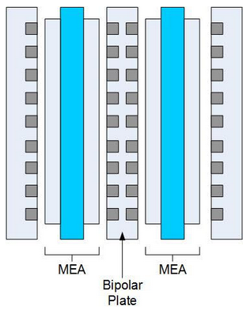
Typical fuel cell stack configuration (a two-cell stack)

Polymer Electrolyte Membrane Fuel Cells (PEMFCs)
The polymer electrolyte (also called proton exchange membrane or PEM) fuel cell delivers high-power density while providing low weight, cost, and volume. A PEM fuel cell consists of a negatively charged electrode (anode), a positively charged electrode (cathode), and an electrolyte membrane, as shown in Figure below. Hydrogen is oxidized on the anode and oxygen is reduced on the cathode. Protons are transported from the anode to the cathode through the electrolyte membrane and the electrons are carried over an external circuit load. On the cathode, oxygen reacts with protons and electrons forming water and producing heat.
In the PEM fuel cell, transport from the fuel flow channels to the electrode takes place through an electrically conductive carbon paper, which covers the electrolyte on both sides. These backing layers typically have a porosity of 0.3 to 0.8 and serve the purpose of transporting the reactants and products to and from the bipolar plates to the reaction site [1]. An electrochemical oxidation reaction at the anode produces electrons that flow through the bipolar plate/cell interconnect to the external circuit, while the ions pass through the electrolyte to the opposing

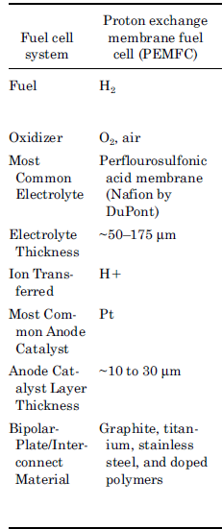 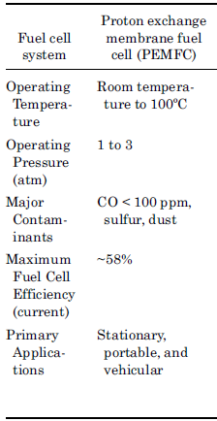 ⁴

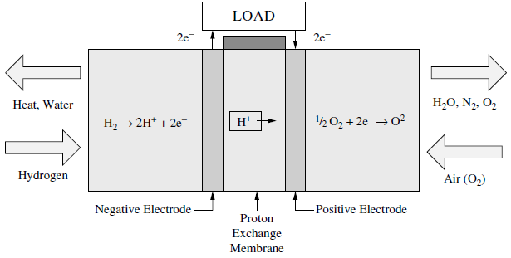
The polymer electrolyte fuel cell (PEMFC) ⁴

electrode. The electrons return from the external circuit, while the ions pass through the electrolyte to the opposing electrode. The electrons return from the external circuit to participate in the electrochemical reduction reaction at the cathode. The reactions at the electrode are

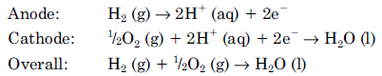

The standard electrolyte material currently used in PEM fuel cells is a fully fluorinated Teflon-based material produced by DuPont for space applications in the 1960s. The DuPont electrolytes have the generic brand name Nafion, and the types used most frequently are 1135, 115, and 117. The Nafion membranes are fully fluorinated polymers that have very high chemical and thermal stability. The electrodes are thin films that are bonded to the membrane. Electrodes with low platinum loading perform as well or better than high-platinumloaded electrodes. To improve the utilization of platinum, a soluble form of the polymer is incorporated into the porosity of the carbon support structure. This increases the interface between the electrocatalyst and the solid polymer electrolyte [2].

  - Basic stationary fuel cell calculations.
In order to evaluate and compare stationary fuel cell systems, the following efficiencies can be calculated for all of the components and aspects of the fuel cell system. The total efficiency of the fuel cell system is defined as:
Total efficiency = (electric power output + thermal output) / fuel consumption

Or 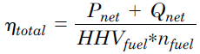 (20)

where P_{net}, and Q_{net} is the usable power and heat amounts respectively, and
n_{fuel} is the amount of fuel input into the fuel cell system. The total efficiency
of the fuel cell system can also be calculated by multiplying the efficiencies
of the individual components, and the ratio of parasitic power and fuel cell
gross power output (ξ_{p}). An example of this equation is as follows:

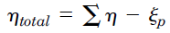 (21)
The electrical efficiency of the stationary fuel system is:
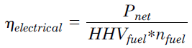 (22)

Where 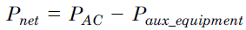 (23)
and (23)

where PAC is the usable AC power generated, P_{aux_equipment} is the power required by auxiliary equipment, P_{compressor} is the power required by compressor, P_{pump} is the power required by the pump, and P_{control} is the power required by the control system.
The thermal efficiency of the stationary fuel cell system is:
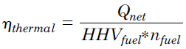 (24)

If the stationary fuel cell system uses a fuel processor, the efficiency of the fuel processor is:
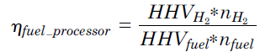 (25)
The DC/AC efficiency of the stationary fuel cell system is:
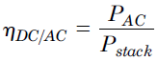 (26)
For any auxiliary equipment used, the efficiency is:
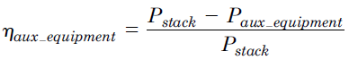 (27)

The efficiency of the fuel cell stack is:
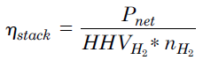 (28)

  - Fuel Cell Reversible and Net Output Voltage
The maximum electrical energy output, and the potential difference between the cathode and anode is achieved when the fuel cell is operated under the thermodynamically reversible condition. This maximum possible cell potential is the reversible cell potential. The net output voltage of a fuel cell at a certain current density is the reversible cell potential minus the irreversible potential which is discussed in this section, and can be written as [3]:
(29)
where V_{rev} = E_{r} is the maximum (reversible) voltage of the fuel cell, and V_{irrev} is the irreversible voltage loss (overpotential) occurring at the cell.
The maximum electrical work (W_{elec}) a system can perform at a constant temperature and pressure process is given by the negative change in Gibbs free energy change (ΔG) for the process. This equation in molar quantities is:
(30)
The Gibbs free energy represents the net energy cost for a system created at a constant temperature with a negligible volume, minus the energy from the environment due to heat transfer. This equation is valid at any constant temperature and pressure for most fuel cell systems. From the second law of thermodynamics, the maximum useful work (change in free energy) can be obtained when a “perfect” fuel cell operating irreversibly is dependent upon temperature. Thus, W_{elec}, the electrical power output is:
(31)
where G is the Gibbs free energy, H is the heat content (enthalpy of formation), T is the absolute temperature, and S is entropy. Both reaction enthalpy and entropy are also dependent upon the temperature. The absolute enthalpy can be determined by the system temperature and pressure and is usually defined as combining both chemical and thermal bond energy. The change in the enthalpy of formation for the chemical process can be expressed from the heat and mass balance:
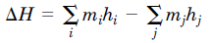 (32)
where the summation of the mass times the enthalpy of each substance leaving the system, and is the summation of the mass times the enthalpy of each substance entering the system. Asimple diagram of the heat and mass balance is shown in Figure below.
The potential of a system to perform electrical work by a charge, Q (coulombs) through an electrical potential difference, E in volts is [4]:
(33)
If the charge is assumed to be carried out by electrons:
(34)

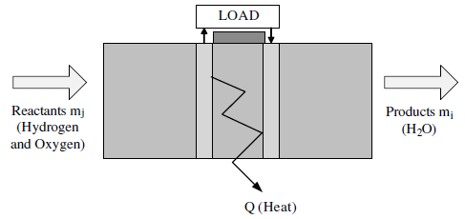
Fuel cell heat and mass balance

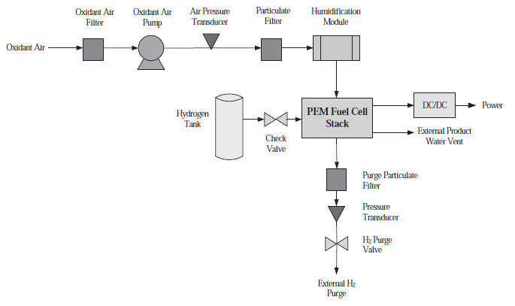
Simple PEM fuel cell system [5]

- Model creation of PEM fuel cell
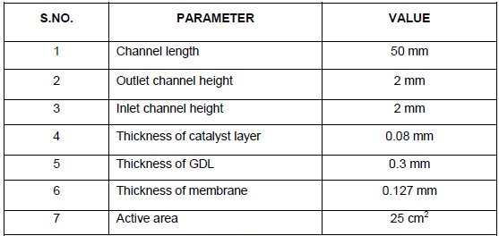
Dimensions of PEM fuel cell model

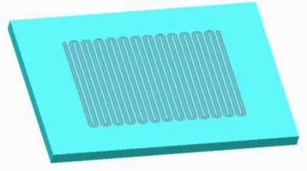
Model of serpentine channel flow field of PEM fuel cell

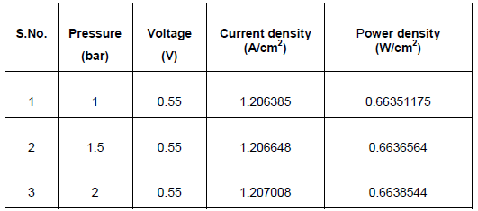
The analysis was done with three different pressure (1 bar, 1.5 bar, 2 bar) and voltage (0.25 V-0.85 V) at constant temperature of 323 K (50oc) using Ansys and checked

  - Material and assembly (exp)
Table below summarises the material properties of the fuel cell components used in this study and Fig below shows the assembly steps of the PEM fuel cell. The optimised OPCF flow plate housing was machined and wiped thoroughly using isopropyl alcohol to ensure that the housing is clean and no dust or grease present. The flow plate housing is placed horizontally in a flat position. OPCF was polished using silicon carbide grinding paper on a polishing wheel. The OPCMF is placed inside the housing and bolts are placed through the housing as shown in Fig below, photo 2. A gasket is then placed into position as shown in Fig below, photo 3. The MEA is positioned onto the housing as shown in Fig below, photo 4. A second gasket is then placed onto the MEA as shown in Fig below, photo 5. A second OPCF flow plate is placed into a second housing as shown in Fig below, photo 6. The second housing is then placed onto the bolts of the first housing. The MEA and gasket positions are checked and both housings are closed. Nuts are placed on the bolts and they are tightened. The push-in fittings for hydrogen pipes are placed in their positions. The final assemble fuel cell is shown in Fig below, photo 7.
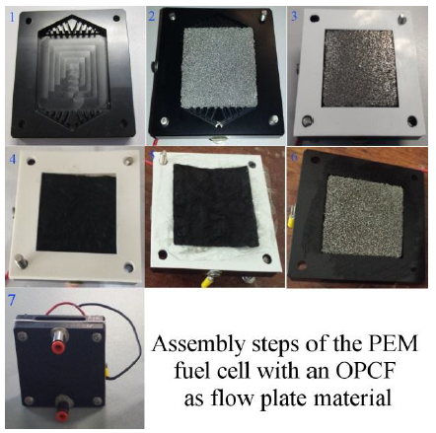
Assembly steps of the PEM fuel cell

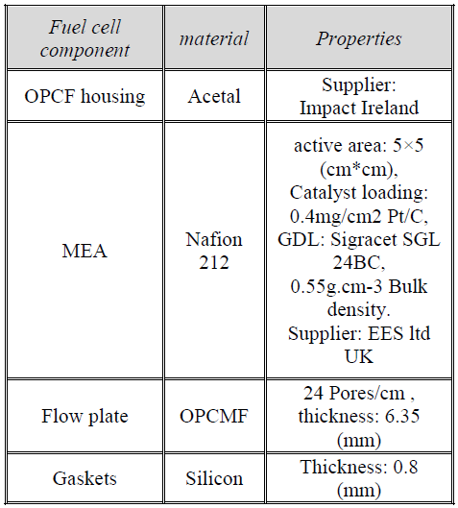
Material properties of the fuel cell component

  - Experimental set-up and procedure ¹⁴
The experimental setup is similar to Carton & Olab [6]. The reactant gas, hydrogen, is stored in a compressed cylinder. A specialized hydrogen pressure controls the hydrogen gas flow pressure. The gas then passes through volumetric flow meters. The flow controllers are calibrated for the hydrogen gas and air. The flow controllers are controlled by the data acquisition (DAQ) software (Lab View). Both air and hydrogen gases were humidified as stated by the manufacturer of the MEA. The open circuit voltage and the fuel cell operating voltage are detected by the DAQ hardware and analyzed through the software. The open circuit voltage reading is also double checked at the anode and cathode using a multi-meter (Fluke 8808A digital multi-meter). The fuel cell current is measured using a multi-meter (Fluke 8808A digital multi-meter) in series with the external load.
Every effort was made to keep parameters constant during the experiments to ensure that the values of resistance, pressure and flow were not changed from one experiment to the next. These parameters were checked throughout the experiment to identify any unwanted errors. The only effect on the performance was that of the flow plate design.

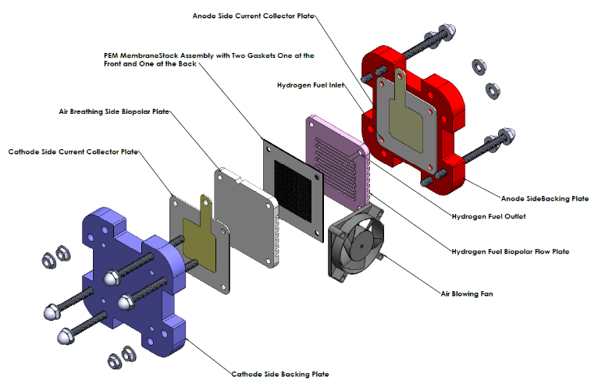
The Polymer Electrolyte Membrane Fuel Cell (PEMFC)

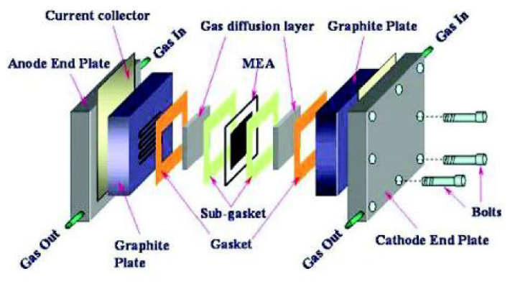
Schematic of Polymer Electrolyte Membrane Fuel Cell showing different components

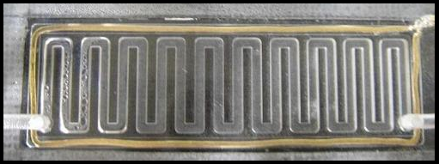
Condensation of water produced by a PEMFC on the air channel wall. The gold wire around the cell ensures the collection of electric current

- Study of PEM Fuel Cell End Plate Design by Structural Analysis Based on Contact Pressure

  - Introduction
Polymer electrolyte membrane fuel cell (PEMFC) is one of the promising technologies for electrical power generation. Presently, PEMFCs utilize solid polymer membrane as an electrolyte and porous carbon cloth/paper as electrode. The electrode and electrolyte together are referred to as the membrane electrode assembly (MEA) which is equipped with bipolar plate (BPP) on both the sides for reactant flow and current collection. A number of such units (single cells) are connected in series and are flanked by endplate at both ends to form a fuel cell stack. Graphite is usually the material of choice for bipolar plates due to its high corrosion resistance but still lighter material is preferred for the endplate [7, 8]. PEMFC has received considerable attention, especially in the automotive sector as the low operating temperature (< 100°C) allows quick start-up and portability [9, 10].

  - Description of Geometry
The geometry considered in the simulation includes the end plates, two bipolar plates, two gaskets, two GDLs, and a membrane. GDLs are joined to the membrane as nonseparable entities. As in common assembly procedure, the membrane is placed in the middle, with GDL on each side, followed by the gasket. This assembly is sandwiched between the bipolar plates and is enclosed by the end plates as shown in Figure above. In the geometry analysis ten bolts are considered with two configurations, one is with all bolts outside the graphite plates and the other one is with all bolts inside the graphite plates.
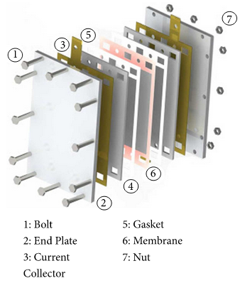
Schematic geometry of PEMFC

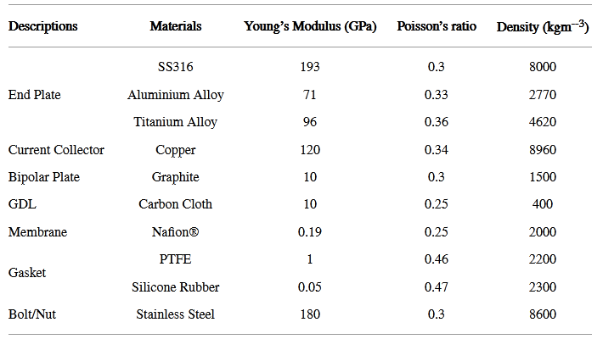
Material properties of PEMFC components

Geometries have been created in SOLIDWORKS and are imported in ANSYS® Academic Research, Release 14.0 workbench. Materials assigned are as shown in the Table 1. The flow channels of the bipolar plate are not included. Gasket material is selected as PTFE. GDL material is selected as carbon paper as it gives good performance due to high porosity (>70%) [6]. The clamping bolts considered are supposed to have standard M10 specifications. While evaluating the geometries, only the change in its external shape is considered, the total physical volume of the plate being kept constant. Reference end plate for the study is as depicted in Figure below.

Case 1 (evaluation of geometry). The size of end plate in our study is 300x200 mm2. Graphite plate, gasket, membrane, and current collector are each of dimension 267 × 172 mm2. Active area for all geometries is constant and it is equal to 199x154 mm2. All design features on end plates have same height of extrusion or cut 2 mm.

Case 2 (effect of number of bolts and position and its effect on contact pressure distribution). After obtaining the results of Case 1, the selected geometry is subjected to analysis in order to determine the effect bolt number and their arrangement.

For each of these schemes, the spacing between the adjacent bolts for each side of the end plate is given by
d = $\frac{L}{n+1}$
where “d” is the distance between adjacent bolts, “L” is the edge length, and n is the number of bolts.

Case 3 (analysis of pressure distribution considering that the bolt passes through the bipolar plate). After completing the analysis in Cases 1 and 2, the geometry and number and bolts are selected. The bolt position is then shifted such that it lies inside the bipolar plate and the change in pressure distribution is determined.

Case 4 (evaluation of the effect of gasket thickness). In most of the previous studies, the BPP is assumed to be in perfect contact with GDL while performing the FEA. However, in most practical scenarios, there is some difference between the gasket and GDL thickness. This mismatch produces an initial no-contact region between BPP and GDL, when compressive forces are gradually applied.

The final geometry obtained after three successive case studies is subjected to further analysis for evaluating the effect of change in the gasket thickness. Gasket thickness is changed in three equal steps from 0.1 to 0.2 mm, keeping the thickness of GDL constant (0.4mm).

Case 5 (evaluation of different end plate materials). The influence of the end plate material on the pressure distribution, stresses, and deformation is investigated using different materials. It is implemented using the configuration chosen after analysing the result of the previous cases.

  - Boundary condition
The current study shall act as a guideline for future fuel cell design activities, since it provides a comprehensive solution for ensuring homogeneous pressure distribution, leakage proof operation, and improving performance.

Several end plate geometries were considered in this study, along with number of bolts used in tightening and their position with respect to the cell. Extruded hexagonal geometry for end plate shows better distribution of contact pressure. Number of bolts is found to have a significant impact on average contact pressure and distribution. In the study, it is found that 10 bolts are suitable for obtaining uniformity for the structure under study. Bolt placement also has a considerable impact on the average contact pressure and contact pressure distribution, i.e., by placing all bolts through the graphite plate has contributed to more uniform contact pressure distribution.

Another important aspect of cell assembly is to choose a gasket thickness complementary to thickness of the GDL for a given compressive pressure. The evaluations of gasket thickness from this study shall provide insights into the permissible gasket thickness. It is found that the difference between GDL and gasket is tolerable between 0.15 mm to 0.2mm. Thus, by optimizing geometry, number of bolts, their position, and gasket thickness, average contact pressure of ~ 0.8 MPa is obtained at a bolt loading of 8–10 Nm. Change in material is found to be of lesser importance. However, lighter materials like aluminium alloys can be effectively utilized, producing weight savings of ~65% while retaining better contact pressure distribution.

- Components in a single cell

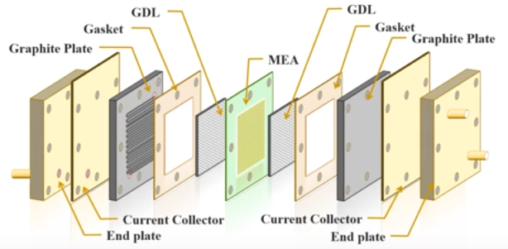
The figure above shows the expansion diagram of a single cell. Inside the single cell, we can see the first of course the MEA which had a no catalyst layer Castle Caturday, and separator which is a counter ionic conductive but electronically is insulate. And next to the MEA is the TDA of gaskets if you layer will be mentioned them. Since the it had to be carried transport the gas in and out so it’s a porous medium and even the outside the oscar of the is also porous so the gas will leak out from the outside here so we need the gasket to prevent gas leakage, and the gas key is made of flexible Teflon, so it’s a chemical inner but also still the guest so that will not let the gas leak of an outside and also acting as a insulation.

Then we call the graphite plate. The graphite plate actually might be the graphite powder or carbon powder mixed with phenolic resin and compressed into a plate and the under surface of the play had a curve into the flow channel so the reactant the guest will be when a flow through the channel will be able to evenly distribute through the GDL to the electrode surface and also the current or electron generation.

And know we flow out through the GDL and to the graphite plate. Because the disk graphite plate is in touch with korg component for the sphere cell is maybe corrosive so it’s had to be used carbon material to make sure it’s when a corrode and but also the current and outside will be the current collector, the current carried out by the current collector an outer cell. The reason we had to need a current collector is the electronic conductivity of the current collector is a more than a thousand times higher than the graphite plate. This current quality usually made of copper maybe but usually is highly electronic conductive but because we use a graphite plate to insolate to prevent any corrosive gas or the environment so they will be not corroded but this will very highly conductive so the current can be disputed evenly through th egraphite plate to the GDL and then we had end plate. The purpule for the end plate is try to contact or transmit the screw pressure even into the center because the channel graphite plate.

The channel plate and then GDL and the electro here need a pressure to compress together to reduce possible interfacial resistance electronically distance between a graphite plate or GDL to the catalyst layer. You need a pressure to press down to reduce the individual pressure but you cannot punch a hole and make a school to tight it up so you had to add a screw tigher on the periphery of the graphite plate to this one had to enough pressure to press on the GDL. So this end plate have a stick and then will become complete the screw pressure to the center even a dispute so that said understand the pressure can be evenly compressed. There’s a basic a key component for a single cell that for the MEA the GDL cascade graphite plate current collector and end plate.
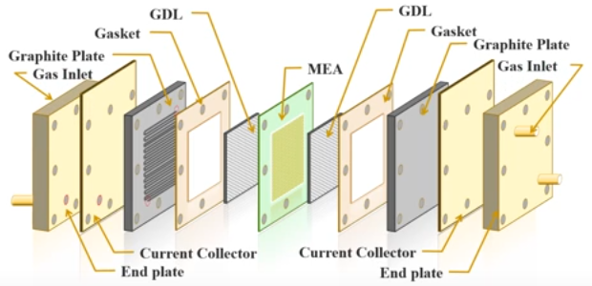

- Fuel cell stack
  - Add cell to the stack
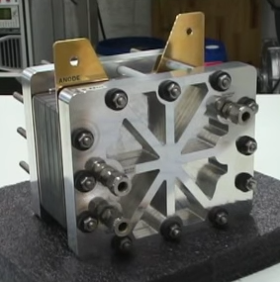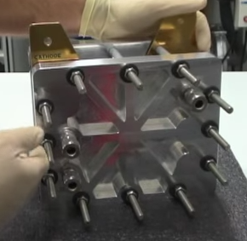
Form the anode’s side From the cathode’s side

We have 5 cells in our hydrogen fuel cell. To add 2 cells to the fuel cell, you must first remove the bolts and nuts
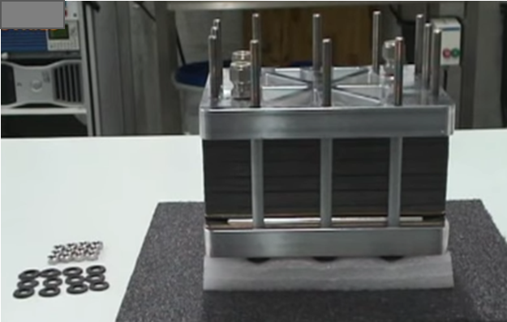

Then we remove the end plate
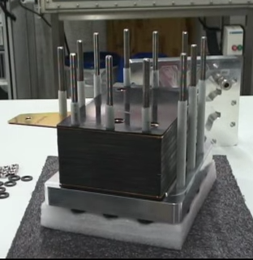

Then we remove the current plate collector, with the gasket
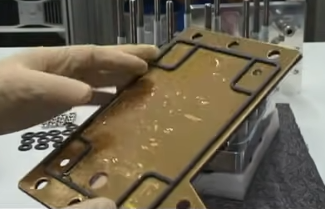

This is what we have. It's the first cell next to the current collector. We can see there is a channel. And this channel is the liquid cooling add in the end plate
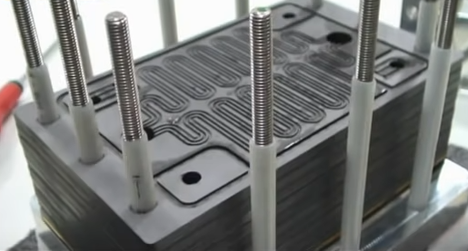

For more details, we will review the details of a single cell. These is the cell itself, so that the components required for single cell. Two graphite plate and one membrane electrode assembly (MEA).
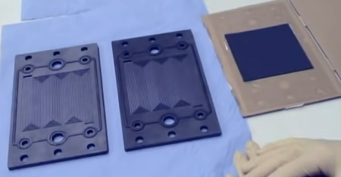

We can see the gasket layers and the subgasket use two support the electrolytic membrane
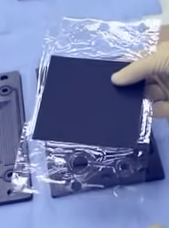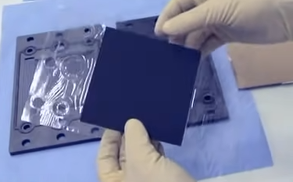

Each plate equiped with the single gasket and the gas distribution channel with multiple support flow field, and field gasket and in the middle holes to field the liquid cool.
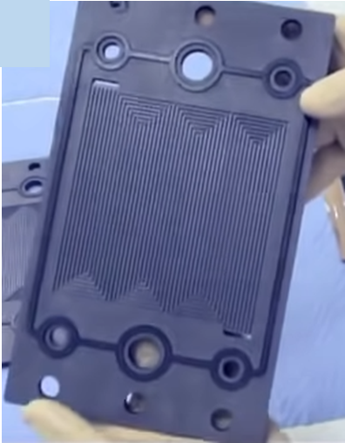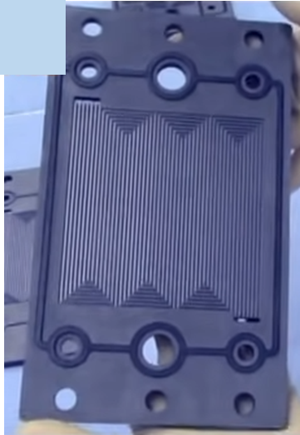

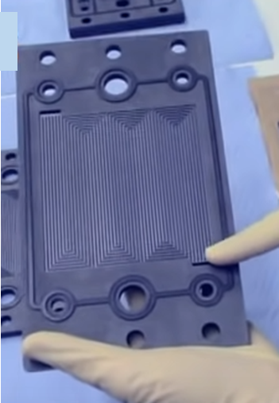

We turn the plate, we can see the hole is connected through the plate.
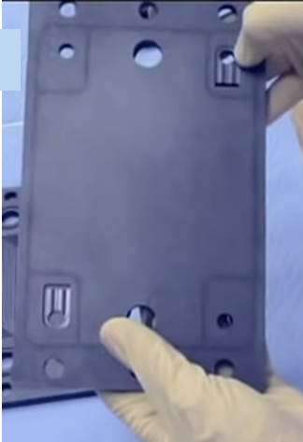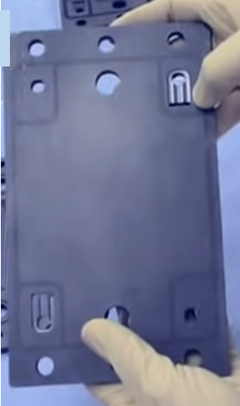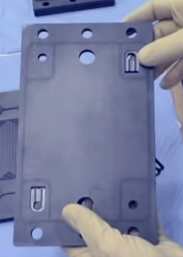

Basicly, how it is made very simple. One plate, from the channel side, one MEA placed on the plate with gasket and the another plate ,with gasket, puted on the MEA like this. And we have like one cell.
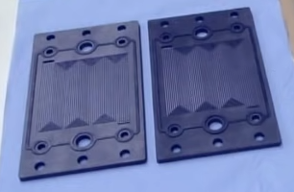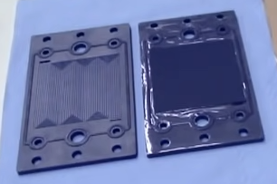

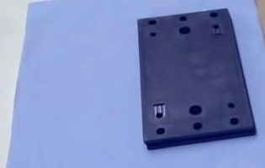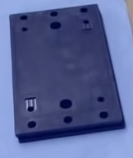

And now, we want to add this cell to the rest of the stack
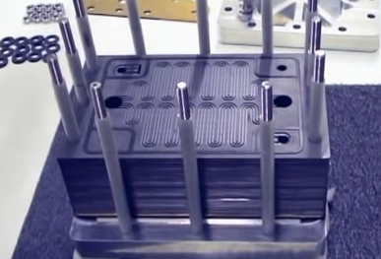

I will first take this plate. We will start with this plate because it is flush. If we have like this gasket is here and cooling channel is here so we will place plate flush.
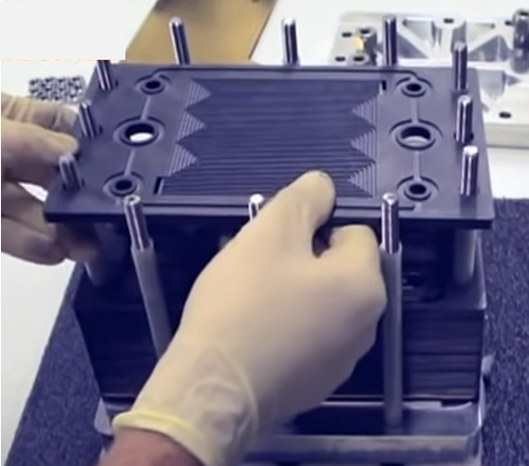
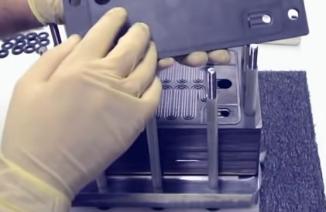

Add the gasket
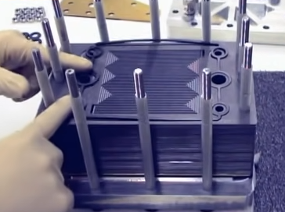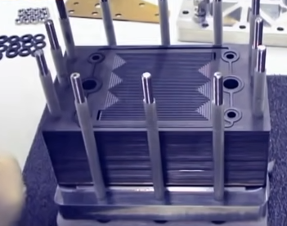

Now we added the MEA
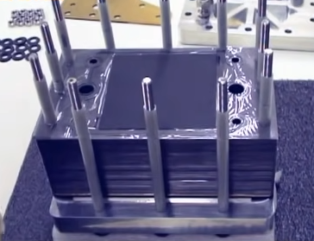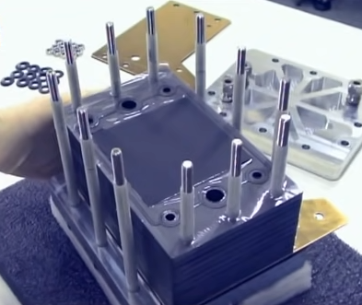

And add the gasket
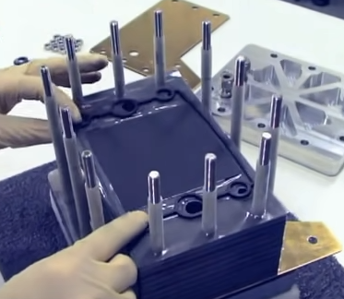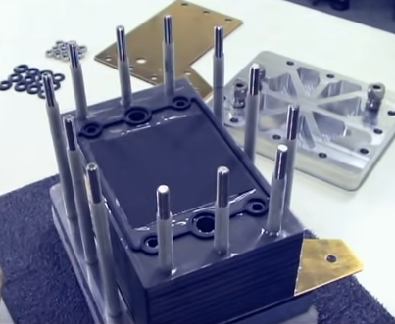

And emplacing the plate through the tie rod.
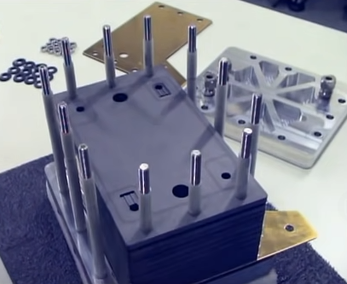

I will now move to add the second cell. I want to add to the stack the cell. we seen before is ready with MEA inside. And this cell is equiped with cooling channel on both side. For a simple reason, the last cell is flush so one cooling channel between the two half plate here and because it will be the last cell in the stack, there is also the cooling channel had is trun the side of the cell
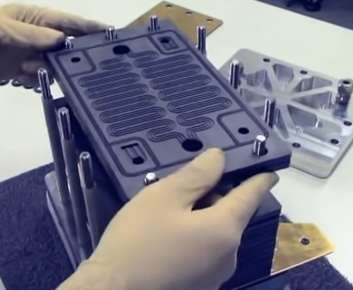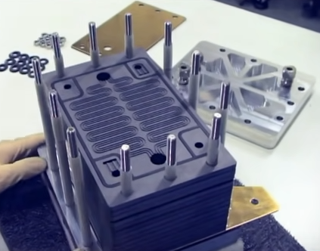

Now what i need is again the current collector. We placed back.
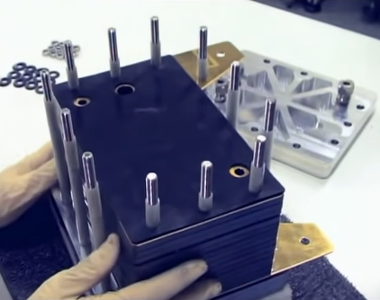

And go nicely to placed the end plate
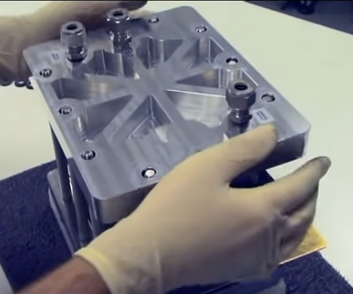

  - Working prototype
How to make a working prototype of such a do-it-yourself hydrogen fuel cell.
To do that, first, we need to make a platinum electrode we’ll use for oxidizing hydrogen and generating electricity . Metallic platinum is a great catalyst, which means it increases the rate of chemical reactions for instance. Since pure platinum is too expensive, to make electrdes from a thin platinum film on the surface of another metal will suffice for my experiment.

I am using such a nickel sponge sheet as a base for my platinum electrode, because Platinum coats this metal quite smoothly and without coming off. It besides because of this spanish sporus structure the surface area is maximized and the obtained catalyst will be extermely effective. Before going platinum plating, we need to remove grease and prepare the surface of the nickel sheet which is why first a large strips of the nickel sponge into an ultrasonic cleaner filled with soap solution. After cleaning nickel for 10 minutes i’m lowering these strips of nickel into a 50 alcohol solution in order to remove vestiges of soap and dirt. When running ultrasonic cleaning cavitation bubbles been released make sure that other dirt is removed from the pores of the nickel sponge. When the strips dried i got two clean electrodes.

Next for coating the nickel electrode with platinum, i’m using a quite expensive chemical called chloroplatinic acid costing 19 euros because this substance easily absorbs moisture from the air and melts. It is stored in sealed ampoules we’ll need an extremely weak solution of this substance, Just seven millimole per liter. First of all, i’m dissolving one gram of cloroplatinic acid in 15 mL of water, fortunately this chemical dissolves very well in water. and after that, i am pouring 9 grs of this solution into another beaker increasing the volume of the solution to 200 mL.

Now, i am lowering a pretty expensive and durable titanium electrode covered in irridium and russinium oxides into the obtained light yellowish solution such electrodes are used in gold and rhodium plating in order for the reaction to run more smoothly and for the solution not to get tainted in such an aggressive medium by the disintegrating anode.

To do platinum plating, i’m allowing a purified nickel sponge into the solution and starting to run electricity through it using my laboratory adapter during this process. Platinum is slowly covering the surface of nickel creating a very thin gray layer because of its slightly grainy structure it took me 20 minutes to cover one electrode with patinum. After that, i’m lowering it into distilled water in order to rinse off vestiges of the electrolyte. In some time, i got such two platinum electrodes for hydrogen batteries of quite good quality the dark areas are completely covered in pure platinum.

The next stage is making a case a hydrogen fuel cell, which i am going to make from two syringe cases. To increase their efficiency i have attached two valves to them which in the future will help me to run oxygen and hydrogen through my setup more smoothly. Now, i’m solderimg one platinum plated electrode to each syringe case using epoxy raisin on top of which i’m going to run chemical reactions.

This seemingly unremarkable film called nafion is the most important components of my hydrogen battery. They are sold as sandwiches in between two protective plastic layers. If we take a look at its chemical structure, from a chemical point of view it resembles teflon which is used to cover frying pans. The difference through is that several sulfur groups are added to the teflon skeleton enabling such a film to pass protons through it, which are hydrogen ions.

after separating nafion film from the protective plastic layer, It needs to be sandwiched in between the syringe cases, which i am also going to glue together the epoxy raisin hardens in 30 minutes. and after that, we can test my do-it-yourself hydrogen fuel cell for the first test.

I’m going to use a balloon filled with hydrogen. Then using a special burner, i began to supply halogen into the lower part of my setup, because these guys is lighter than air and it will be rising up towards the platinum catalyst. The upper syringe case will be filled with just air 20% of which is oxygen and i think it will be enough for my experiment as i start supplying hydrogen.

We can notice that the multimeter shows how the voltage is beginning to increase and it means that my setup works in some time the voltage reached 0.7 volt and remains more or less stable at this level. When i supply air through the upper part of the cell. The voltage slightly changes but not for long. So, what is happening here and how does this hydrogen fuel cell work.

To explain in simple terms, electricity in my cell is generated in the very middle at the interface of the two platinum electrons upon closing of the circuit when hydrogen is streamed into the lower part of the setup towards the surface of the lower platinum electrode. It gives off its electron which runs through the wire. The ion of hydrogen being created, or in other words proton which passes through that very naphthene film and ends up on the upper electrode there it is oxidized by the oxygen in the ear and receives the electron from the other electrode creating water.

As a result the lower electrode is negative or is an anode and the upper electrode is positive or in other words is cathode. in some time, there even condensed some water on the upper part of my setup which is a main by-product of this battery. My cell generates 0.7 V out of 1.3 theoretically possible. However the intensity of current isn’t very high being just 15 mA that is why unfortunately i won’t be able to connect anything to my hydrogen battery. The only way to increase the energy conversion efficiency of my battery is to make a more concentrated source of hydrogen.

For instanc to use sodium borohydride solution instead this compound can frequently be encountered at organic synthesis laboratoires, it is often used for reducing organic compounds because sodium borohydride easily gives off its hydrogen. It does is so easily than when dissolved in water. We can even see how bubbles are gradually being released from the sodium borohydride solution because this chemical isn’t stable in water and quickly breaks down.

If i turn my setup upside down and pour some sodium borohydrides into the upper part of the cell. I’ll immediately see how the multi-meter detects an increase in the voltage because in this case i am pouring concentrated hydrogen. Alright on the electrode thus, i can achieve high efficiency of my do-it-yourself hydrogen fuel cell having reached the maximum possible voltage. Unfortunately through not even sodium borohydride can increase the intensity of the electric current because my battery is too primitive because i cannot make a more efficient and beautiful fuel cell to continue my experiments.

- Fuel Cell Materials
  - Electrolyte Layer
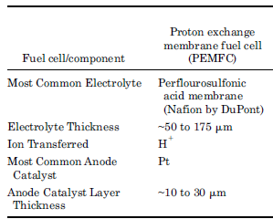
Common Materials Used for Each Fuel Cell Type

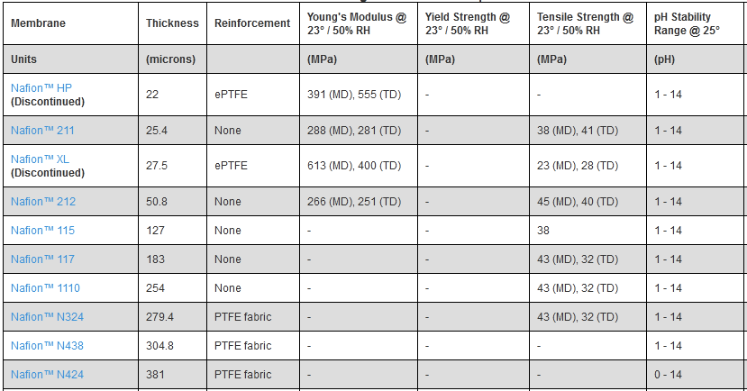

Cation Exchange Membrane Comparison Chart

  - Fuel Cell Electrode Layers - PEMFC catalysts

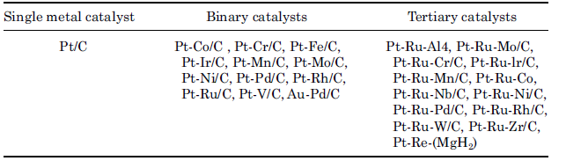
Anode catalyst materials

  - PEMFC gas diffusion layers

The gas diffusion layer is between the catalyst layer and the bipolar plates. In a PEMFC, the fuel cell layers (MEA) are sandwiched between flow field plates. On each side of the catalyst layer, there are gas diffusion backings. They provide electrical contact between the electrodes and the bipolar plates, and distribute reactants to the electrodes. They also allow reaction product water to exit the electrode surface and permit the passage of water between the electrodes and the flow channels.

Gas diffusion backings are made of a porous, electrically conductive material (usually carbon cloth or carbon paper). An illustration of carbon cloth and Toray paper is shown in Figure below. The substrate can be treated with a fluoropolymer and carbon black to improve water management and electrical properties. These material types promote effective diffusion of the reactant gases to the membrane/electrode assembly. The structure allows the gas to spread out as it diffuses to maximize the contact surface area of the catalyzed membrane. The thicknesses of various gas diffusion materials vary between 0.0017 to 0.04 cm, density varies between 0.21 to 0.73 g/cm2, and the porosity varies between 70 and 80 percent.

The GDL also helps with managing water in PEMFCs because it only allows an appropriate amount of water vapor to contact the membrane electrode assembly to keep the membrane humidified. In addition, it promotes the exit of liquid water from the cathode to help eliminate flooding. This layer is typically wet-proofed to insure the pores in the carbon cloth or paper do not become clogged with water. The most common wet-proofing agent is PTFE.
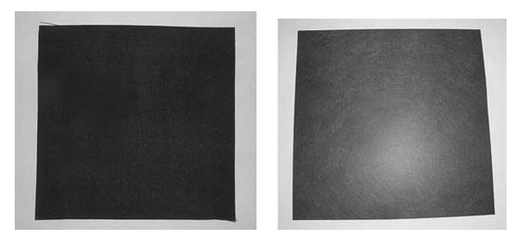
Carbon cloth and toray paper ( picture courtesy of Fuel Cell Scientific )

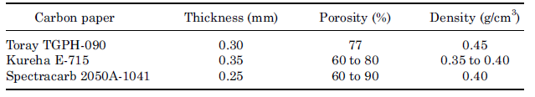
Properties of Commercially Available Carbon Papers Used as Substrates In PEMFC Electrodes

- Constructing the Fuel Cell Bipolar Plates, Gaskets, End Plates, and Current Collectors

  - Bipolar plate design
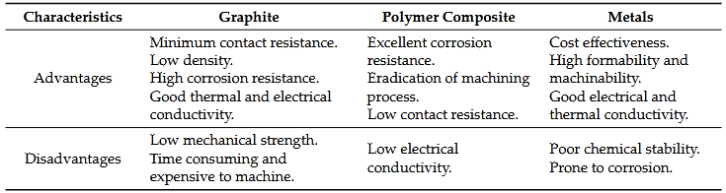
Properties of various types of bipolar plates for PEM fuel cells

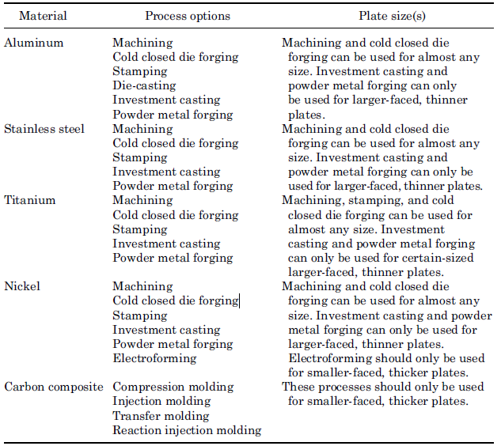
Process Options for Bipolar Plates

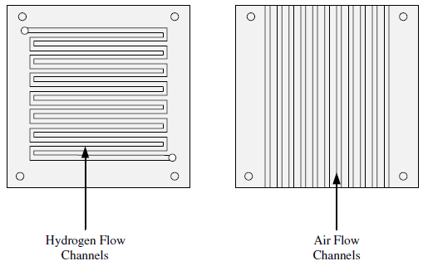
Bipolar plate design for hydrogen and air flow channels for a PEMFC

  - Gasket selection
For the small air-breathing stack 0.010 or 0.020-inch silicone gaskets can be used (depending upon the fuel cell [MEA] thickness). Another popular option is using a 0.010-inch thick fiberglass reinforced silicone rubber anode gasket, and a 0.010-inch thick furan cathode gasket. The gasket is placed around the flow fields next to the electrode/diffusion layers to create a seal to prevent gas leakage.

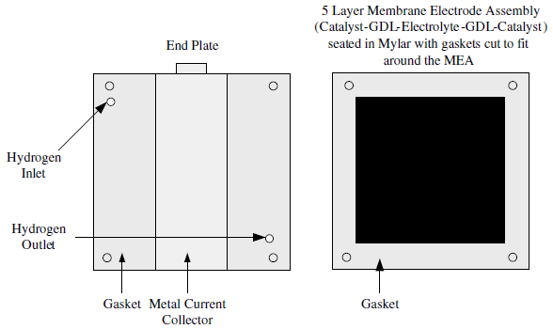
Gaskets, end plate, and MEA for PEMFC

  - End plates
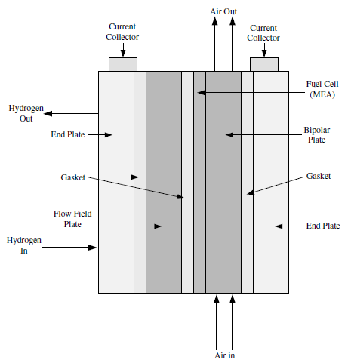
End and flow field plates, gaskets, current collectors, and MEA for a single-cell PEMFC stack

-------------------------------------------------------------------

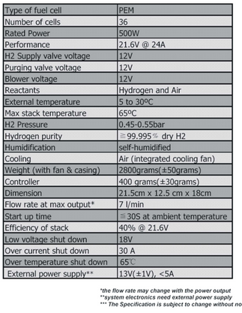

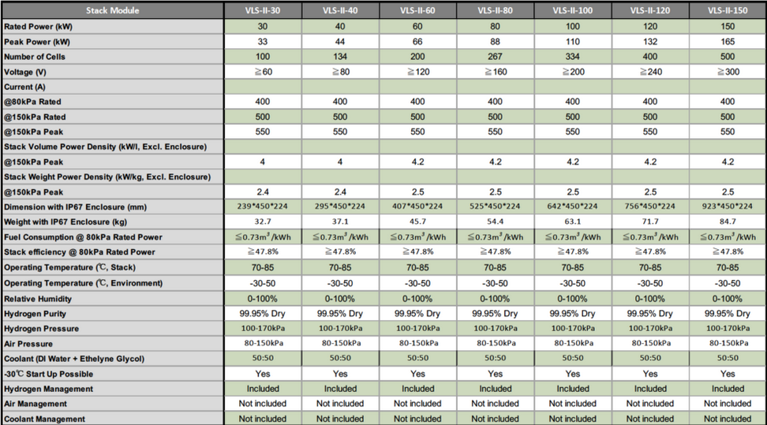

Literature
…

References
[1] Mikkola, Mikko. “Experimental Studies on Polymer Electrolyte Membrane Fuel Cell Stacks.” Helinski University of Technology, Department of Engineering Physics and Mathematics, Masters Thesis, 2001.

[2] Lin, Bruce. “Conceptual Design and Modeling of a Fuel Cell Scooter for Urban Asia.” Princeton University, Masters Thesis, 1999.

[3] Hussain, M.M., J.J. Baschuk, X. Li, and I. Dincer. “Thermodynamic Analysis of a PEM Fuel Cell Power System.” International Journal of Thermal Sciences. 2005. Vol. 44, pp. 903–911.

[4] O’Hayre, Ryan, Suk-Won Cha, Whitney Colella, and Fritz B. Prinz. Fuel Cell Fundamentals. 2006. New York: John Wiley & Sons.

[5] Ibid.

[6] J.G. Carton and A.G. Olab, “Design of experiment study of the parameters that affect performance of three flow plate configurations of a proton exchange membrane fuel cell”, Energy, 35 (7), pp 2796-2806, 2010.

[7] B. C. Steele and A. Heinzel, “Materials for fuel-cell technologies,” Nature, vol. 414, no. 6861, pp. 345–352, 2001.

[8] J. Zhang, J. Wu, H. Zhang, and J. Zhang, Pem Fuel Cell Testing and Diagnosis, Elsevier, Oxford, UK, 2013.
[9] R. O'Hayre, S-.W. Cha, W. Colella, and B. F. Prinz, Fuel Cell Fundamentals, John Wiley & Sons, Oxford, UK, 2nd edition, 2009.
[10] M. Ji and Z. Wei, “A review of water management in polymer electrolyte membrane fuel cells,” Energies, vol. 2, no. 4, pp. 1057–1106, 2009.

https://www.researchgate.net/publication/309898224_A_review_on_prognostics_and_health_monitoring_of_proton_exchange_membrane_fuel_cell/download
https://www1.eere.energy.gov/hydrogenandfuelcells/pdfs/fct_h2_fuelcell_factsheet.pdf
https://www.youtube.com/watch?v=4a88VxnORIo
https://www.youtube.com/watch?v=yrAAVOgBmcE
https://www.energy.gov/eere/fuelcells/fuel-cells
https://www.sciencedirect.com/book/9780123742599/pem-fuel-cell-modeling-and-simulation-using-matlab
https://www.fuelcellstore.com/fuel-cell-education-products/educational-media/designing-and-building-fuel-cells-Speigel-hardcover
https://www.scribd.com/document/447288677/Design-and-Control-of-Fuel-Cell-System-for-Tran-z-lib-org-pdf
https://bz.vdma.org/documents/266669/49673320/FuelCellProductionBrochures_FuelCellComponents_Edition1_online_en_PEM_v07_scn_1606398023504.pdf/35fca3ae-b8e5-37e6-a685-d2dcae8a3d15
https://www1.eere.energy.gov/hydrogenandfuelcells/pdfs/fct_h2_fuelcell_factsheet.pdf
https://bz.vdma.org/documents/266669/49673320/FuelCellProductionBrochures_FuelCellComponents_Edition1_online_en_PEM_v07_scn_1606398023504.pdf/35fca3ae-b8e5-37e6-a685-d2dcae8a3d15
file:///C:/Users/admin/AppData/Local/Temp/ThermalEngineeringPerfEvaluationofaPEMFCstackatpartialload.pdf
https://www.researchgate.net/publication/341095046_IMPACT_OF_PRESSURE_ON_THE_PERFORMANCE_OF_PROTON_EXCHANGE_MEMBRANE_FUEL_CELL
https://www.researchgate.net/publication/265412592_Design_and_Development_of_Proton_Exchange_Membrane_Fuel_Cell_using_Open_Pore_Cellular_Foam_as_Flow_Plate_Material/download
https://wlv.openrepository.com/bitstream/handle/2436/621478/AAM-A%20Baroutaji-%20Developments%20of%20electric%20cars%20and%20fuel%20cell%20hydrogen%20electric%20cars-Wire.pdf?sequence=8
https://www.researchgate.net/publication/282896560_Proton_Exchange_Membrane_Fuel_Cell_Technology_India's_Perspective/download
https://www.hindawi.com/journals/jen/2019/3821082/
https://www.fuelcellstore.com/blog-section/fuel-cell-materials-blog-articles/membrane-comparison-chart-2021
https://www.mdpi.com/1996-1073/11/11/3203/htm
https://www.google.com/imgres?imgurl=http%3A%2F%2Fwww.hhomart.com%2Fimg%2Fcms%2FPEMFC%2520500w%2520Specs.jpg&imgrefurl=https%3A%2F%2Fwww.hhomart.com%2Fen%2Ffuellcell%2F6-500w-pem-fuel-cell-stack.html&tbnid=0ZzJW5PkHVmXeM&vet=12ahUKEwi9ga6k7JnzAhUPTBoKHSmHBHwQMygZegUIARDSAQ..i&docid=EmtxcOEaOV26XM&w=2066&h=2725&q=dimension%20of%20fuel%20cell&client=firefox-b-d&ved=2ahUKEwi9ga6k7JnzAhUPTBoKHSmHBHwQMygZegUIARDSAQ
https://fuelcellsworks.com/news/throwback-thursday-spotlight-horizon-automotive-pem-fuel-cells-to-set-300kw-benchmark/

