Plant Details
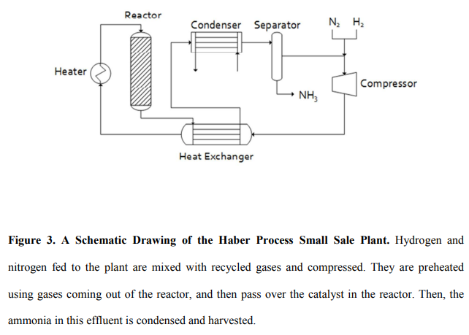
The ammonia synthesis plant that is the key to these experiments is shown schematically in Figure 3.
The entire system is powered by electricity either produced by a 1.65 MW wind turbine (Vestas, Hedeager 42, Denmark) or from the local utility (Ottertail Power Company, Fergus Falls, MN).
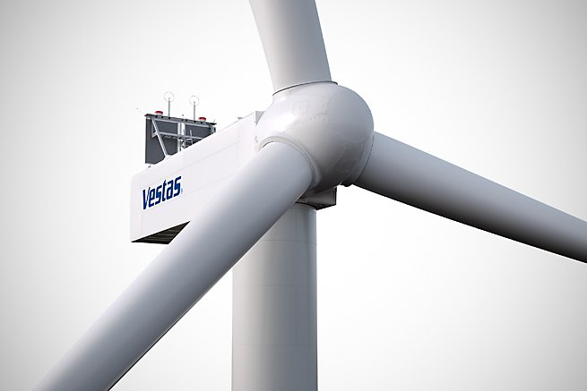
Figure 1 Wind turbine
Nitrogen is produced by an Innovative Gas Systems NS-10 pressure swing adsorption system (Grosseto, Italy).
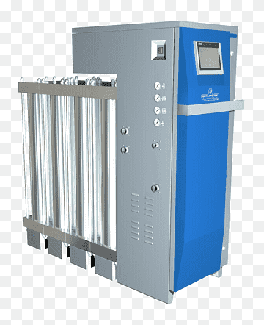
Figure 2 Pressure swing adsorption system
The nitrogen it produces, which is greater than 99.9% pure, is stored at ambient temperature of 165 bar pressure in 18 tanks, each with a volume of 0.05 m3 (Norris Cylinder Company, Longview, TX).
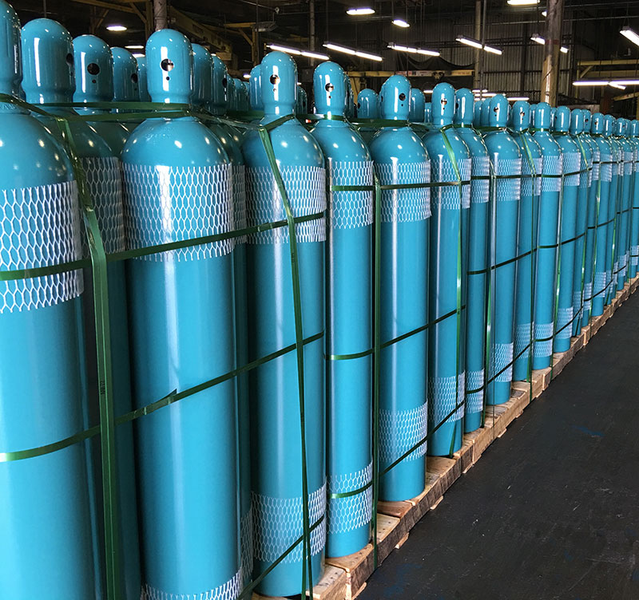
Figure 3 Norris Cylinder
Hydrogen, which is manufactured by a Proton Onsite Hogen H6 (Wallingford, CT), is over 99.9% pure after it is dried across phosphorus pentoxide. It is stored at ambient temperature and 165 bar pressure in 54 0.050 m3 tanks identical with those for nitrogen. Both these systems function properly; occasionally the hydrogen production was marginally less than the amount required for the synthesis.
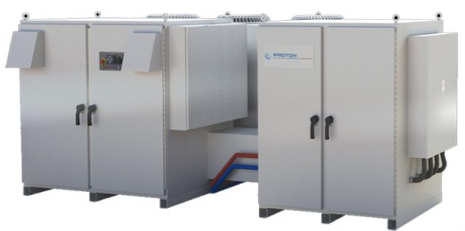
Figure 4 Proton onsite - Hydrogen energy and innovative gas solutions
The nitrogen and hydrogen flow through orifice meter (Imperial Flange & Fitting Company Inc., Los Angeles, CA) into the main system, where they are combined with recycled gases coming from the separator.
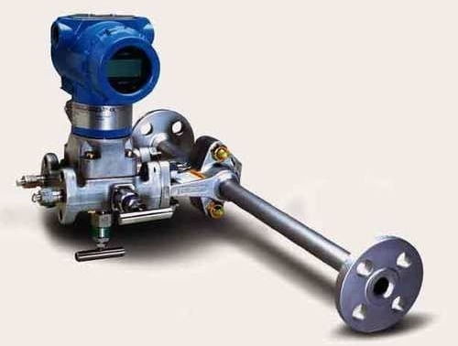
Figure 5 Orifice meter
These mixed gases, at 83 bar, enter a RIX Industries 4VX1BG-1.7 (Benicia, CA) compressor.
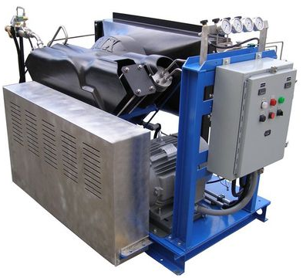
Figure 6 Piston compressor 4VX
The exiting gases leave at a pressure of about 145 bar and flow to a train of four double pipe heat exchangers, where they are warmed using the gases that are discharged from the reactor.
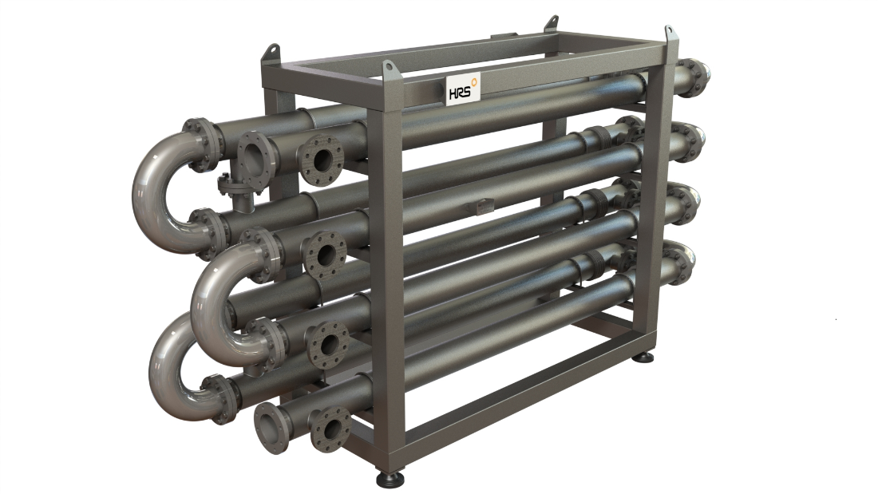
Figure 7 Industrial Double tube heat exchangers
The inner pipe of each heat exchanger (Sep-pro Systems Inc., Houston, TX) has:
- an inside diameter of 0.013 m
- a length of 20.3 m,
- giving a total interfacial area of 0.83 m².
These gases, now at the pressure of about 145 bar, flow to a 20 kW heater (Sep-pro Systems Inc., Houston, TX) where they can be heated to reactor temperature.
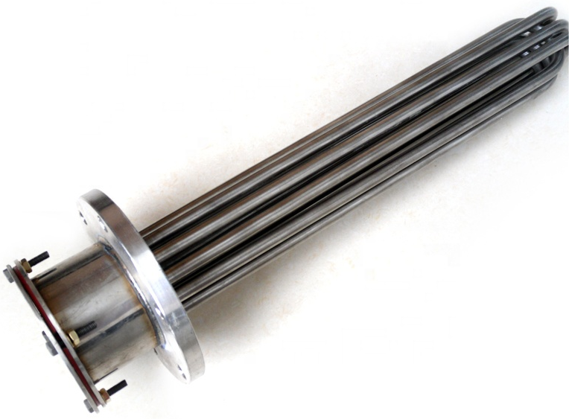
Figure 8 Electric water 20 kW heater
The hot gases then flow to the reactor (Consolidated Inc., Gary, IN).
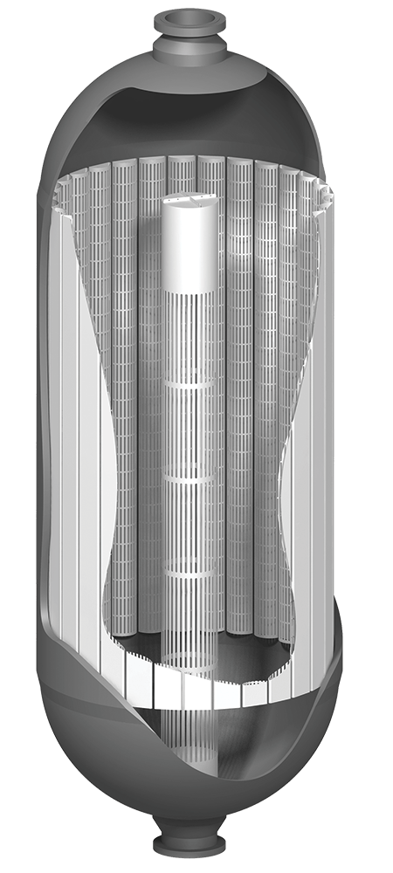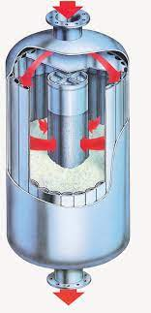
Figure 9 Radial flow reactor
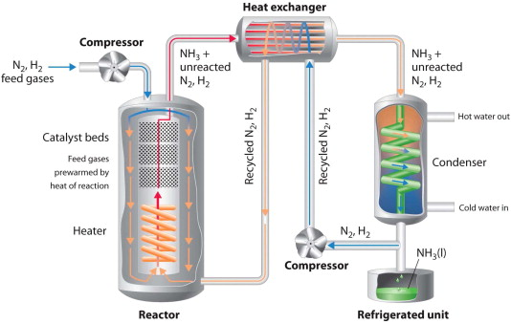
The reactor is:
- 2.23 m long
- 0.203 m in diameter
- sealed with a metal O-ring made out of stainless steel.
- Tightening this O-ring to avoid leaks requires considerable care using hydraulic torqueing of the bolts that secure the top flange to the reactor body.
- Within the reactor, the catalyst is contained in an annular basket (Consolidated Inc., Gary, IN) 1.8 m long, and 0.152 m outer diameter.
- To load the catalyst, the top flange is removed and the catalyst is dumped into the basket.
The reagent gas feeds into the lumen of this annular space and flow radially out through the catalyst.
The particular catalyst used is AmoMax-10 (Sud-Chemie, Louisville, KY).
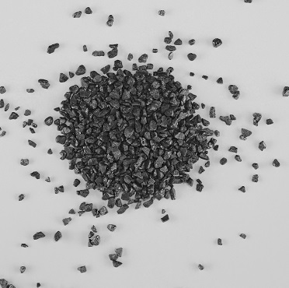
Figure 10 AmoMax 10
The gases exiting from the reactor flow back through the shell side of the heat exchanger, and so pre-heat the reactive feed.
These gases now flow to the condenser.
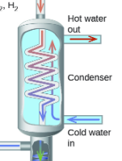
Figure 11 Condenser
The condenser (Sep-pro Systems Inc., Houston, TX) has:
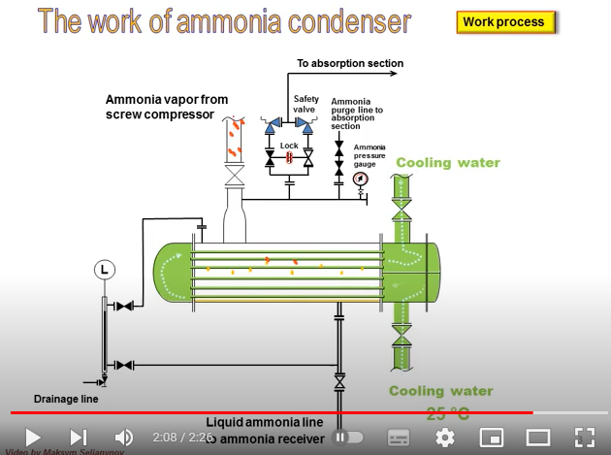
- 1 tube 8.4 m long and 0.013 m in diameter, giving a condenser surface area of about 0.34 m².
- A refrigeration skid (Sep-pro Systems Inc., Houston, TX) drives the refrigerant, R-404A (Copeland, Sidney, OH), through a 8.4 m long and 0.025 m diameter outer shell around the condenser tube.
It operates at about -20°C. The resulting gases exit from the condenser at a temperature around -17°C and flow to the separator, a flash drum.
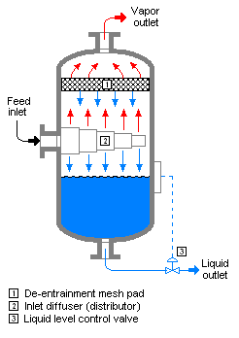
Figure 12 Vapor liquid separator
The flash drum separates the ammonia liquid. Ammonia separated in the flash drum exits the plant through a solenoid valve and flows to a larger storage tank. The ammonia collected is stored in an 11.7 m³ storage tank (WestMor Industries, Morris, MN) at a pressure of 10 bars. The uncondensed gases are mixed with the incoming feed and recycled back into the compressor to start the process again.
The piping used for this plant is made from two different material:
- carbon steel and stainless steel. Most tubing is purchased from Swagelok (Chaska, MN).
Embrittlement with hydrogen is always a problem. All tubing is fixed inside the pilot skid. Unless the tubing is stressed, the risk of leaking is very small. However, the corrosive nature of ammonia worsens the situation.
- Typically, in the tubing through which the hot gas mixture is transported between heat exchanger and reactor, stainless steel 316L is employed because it is more resistant toward corrosion by hot ammonia.
- In the tubing through which the low temperature gas mixture is transported between heat exchanger, separator and compressor, carbon steel is used. Carbon steel has higher resistance toward high pressure with longer life time in the presence of hydrogen.
The chief difficulties in start-up were plumbing the vent ports on the mixed gas compressor and leaks throughout the skid. Holes on the side and bottom of the reactor, which had been drilled for testing, also leaked and so were welded shut by a certified R-stamp welder. Some of the equipment also had material that was not compatible with ammonia and had to be replaced or repaired. Significant effort was required to understand and program the control systems.
Now that the small plant is capable of producing extended runs at steady state, we are able to subject its performance to the analysis described in the theory section.
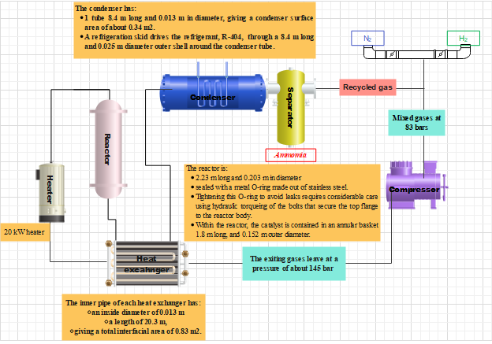
Device | Cost $
Compressor | 6250.00 $
Heater 20 kW
Heat exchanger
Reactor
Condesner
SEparator
PIPES
Valves

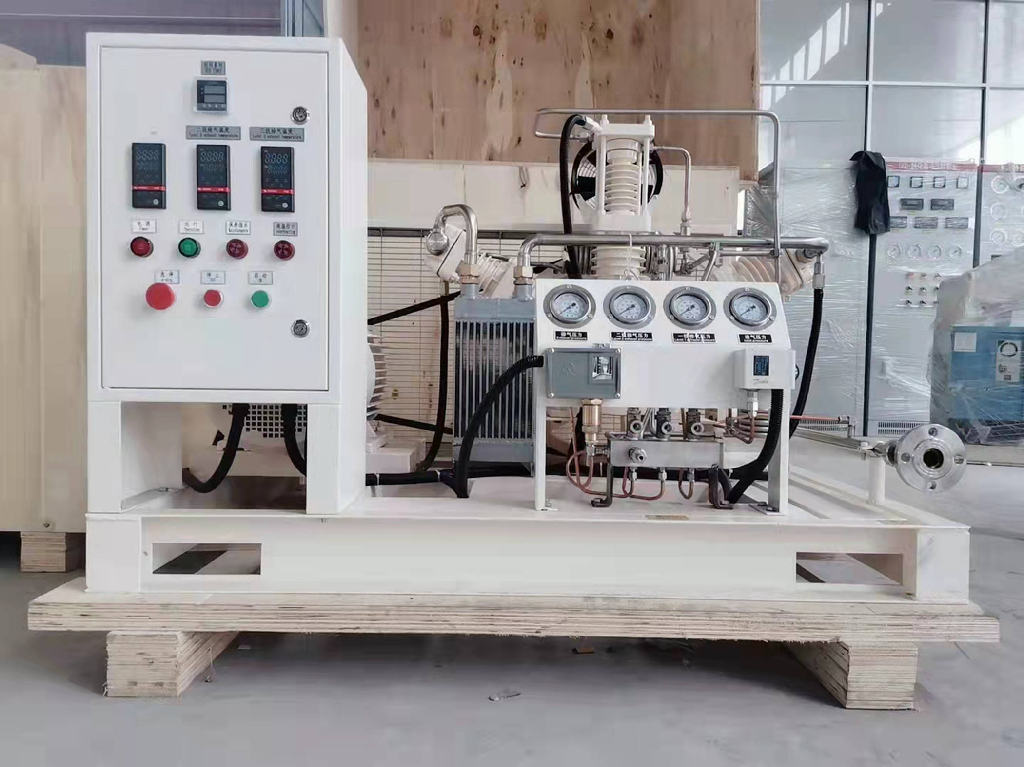
Figure 13 Compressor

